

INTEGRATED CODING EDUCATION & COMPETITIVE PROGRAMMING PLATFORM

Software Requirement Specification


CVerify
AI-Native Evidence-Based IT Talent Platform

Software Requirements Specification (SRS)
Version 2.1 | May 2026

Course | SWP391
Institution | FPT University – Da Nang
Status | Draft – Internal Review
Confidentiality | Confidential – CVerify Team

Team members
Number | Full name | Student ID | Role
1 | Nguyễn Hoàng Ngọc Ánh | DE200147 | Leader
2 | Đoàn Thế Lực | DE200523 | Member
3 | Trương Văn Hiếu | DE190105 | Member
4 | Nguyễn La Hòa An | DE201043 | Member
5 | Trần Nhất Long | DE200160 | Member

Table of Contents
Software Requirements Specification (SRS) 1
Team members 2
Table of Contents 2
Software requirements: What, why, and who 7
CHAPTER 1: The Essential Software Requirement (What, Why, and Who) 7
1. WHAT (The Core Capability) 7
2. WHY (The Business Value) 7
3. WHO (The Stakeholders & User Classes)
Requirements must be balanced among competing stakeholder interests 7
CHAPTER 2: Requirements from the Customer's Perspective 8
1. The Candidate's Perspective: "Empowerment through Transparency" 8
2. The Recruiter's Perspective: "High-Signal, Low-Noise Intelligence" 8
CHAPTER 3: Good Practices for Requirements Engineering 9
CHAPTER 4: The Business Analyst 10
1. INTRODUCTION 11
1.1 Purpose of the Document 11
1.2 Document Conventions 12
1.3 Intended Audience and Reading Suggestions 13
1.4 Definitions, Acronyms, and Abbreviations 14
1.5 Project Scope 15
1.5.1 In-Scope (MVP Boundary) 15
1.5.2 Out-of-Scope (Future Enhancements) 16
1.6 References 16
2. PROJECT OVERVIEW 17
2.1 Project Summary 17
2.2 System Objectives 18
2.3 Technology Stack 19
3. BUSINESS REQUIREMENTS 21
3.1 Business Problems to Solve 21
3.2 Business Objectives & KPIs 23
4. STAKEHOLDERS AND USER CLASSES 25
4.1 Stakeholder Overview 25
4.2 User Classes and Characteristics 26
4.3 Use Case Diagrams & Workflow Mapping (Sẽ chỉnh sửa thêm UC) 26
4.3.1 System Overview (Actor Interaction) 27
4.3.2 Login 28
4.3.3 Authentication & Onboarding Flows 29
4.3.4 Business Onboarding 30
4.3.5 AI Flow 31
4.3.6 Admin dashboard 32
4.3.5 System Monitoring 33
5. PRODUCT SCOPE 34
5.1 Context Diagram – System Overview 34
5.2 System Architecture Overview 36
Tier 1: Presentation Layer (Client) 36
Tier 2: API Gateway & Security Layer 36
Tier 3: Core Business Logic & Orchestration 36
Tier 4: AI Orchestration Layer (Multi-Model Router) 36
Tier 5: Data Persistence & Semantic Storage Layer 37
6. OVERALL SYSTEM DESCRIPTION 38
6.1 Product Perspective 38
6.2 Operating Environment 38
6.3 Design and Implementation Constraints 40
6.4 Assumptions and Dependencies 41
6.4.1 Assumptions 41
6.4.2 Dependencies 41
7. FUNCTION??? 42
7.1 Functional Modules Summary Table 42
7.2 Key Architectural Shifts from v1.0 to v2.0 46
8. AUTHENTICATION AND AUTHORIZATION REQUIREMENTS 47
8.1 Authentication Requirements 47
8.2 Authorization and RBAC Requirements 48
8.3 Session and Security Management Requirements 49
8.4 Detailed Requirement Specifications 50
8.4.1 Detailed Requirement Sample – FR-01: Candidate Registration 50
8.4.2 Detailed Requirement Sample – FR-07: Internal Workspace RBAC 52
9. CANDIDATE MODULE REQUIREMENTS 53
9.1 Profile Management 53
9.2 GitHub/GitLab Repository Integration 54
9.3 AI Skill Analysis & Scoring 55
9.4 Business Rules for Candidate Integrity 56
10. RECRUITER AND COMPANY MODULE REQUIREMENTS 57
10.1 Company Onboarding & Governance 57
10.2 Job Description (JD) Management 58
10.3 Manual Recruitment (Tier 1) 59
10.4 AI-Powered Recruitment (Tier 2) 60
10.5 Business Rules for Recruiter/Company Module 61
11. AI MODULE REQUIREMENTS 62
11.1 AI Architecture Overview 62
11.2 AI Model Routing & Optimization Strategy 62
11.3 AI Governance, Security & Feedback Loop 63
11.4 Pipeline 1: Repository Intelligence (Ingestion & Analysis) 63
11.5 Pipeline 2: Candidate Evaluation & Skill Tree 64
11.6 Pipeline 3: Semantic JD Matching & Ranking 64
11.7 Pipeline 4 64
11.8 Constraints and Limitations 64
12. ADMINISTRATOR MODULE REQUIREMENTS 65
12.1 Administrative Security & Governance 67
12.2 Dashboard Usability 67
13. SYSTEM OPERABILITY & DISASTER RECOVERY 68
13.1 Platform Observability & Monitoring 68
13.2 Data Backup & Recovery (Disaster Recovery) 68
13.3 Incident Response Protocol 69
13.4 Capacity Planning & Scaling 69
14. EXTERNAL INTERFACE REQUIREMENTS 70
14.1 User Interface (UI) Requirements 70
14.2 Software Interfaces (Third-Party APIs) 70
14.3 Communication Interfaces 72
15. DATA REQUIREMENTS 73
15.1 Data Dictionary – Core Entities 73
15.1.1 users 73
15.1.2 candidate_profiles 73
15.1.3 cv_embeddings 74
15.1.4 repositories 74
15.1.5 organizations 74
15.1.6 job_posts 75
15.1.7 applications 75
15.1.8 audit_logs 75
15.1.9 notifications 76
15.1.10 credit_transactions 76
16. DATABASE REQUIREMENTS AND ERD 77
16.1 Logical Data Model – Entity Relationships 77
16.2 Vector Embedding & Semantic Search Architecture 77
16.3 Database Requirements 78
16.4 ERD Architecture 79
16.4.1 AI Recruitment ERD 80
16.4.2 AI Recruitment ERD 81
16.4.3 :Master CVerify Platform ERD 81
16.4.4 Repository Intelligence ERD 81
16.4.5 Trust Intelligence 82
16.4.6 Verification Platform ERD 83
17. NON-FUNCTIONAL REQUIREMENTS 84
17.1 Performance Requirements 84
17.2 Security Requirements 85
17.3 Reliability and Availability 86
17.4 Maintainability and Scalability 86
17.5 Usability Requirements 87
17.6 Privacy and Compliance 87
18. BUSINESS RULES 88
19. UI/UX REQUIREMENTS AND PROTOTYPE 89
19.1 Design System 89
19.2 Key UI Requirements 90
19.3 Prototype / Wireframe 90
19.4 Actual Implementation Screen Flow (Screenshots) 91
PART 1 — ENGINEER WORKFLOW (CANDIDATE) 91
PART 2 — BUSINESS WORKFLOW (RECRUITER) 97
20. REQUIRED DIAGRAMS IN THE SRS 100
21. REQUIREMENT VALIDATION, TRACEABILITY AND CHANGE MANAGEMENT 102
21.1 SRS Completeness Checklist 102
21.2 Requirements Traceability Matrix (RTM) 103
21.3 Change Management Process 103
21.4 Version History 104
22. RELATED WORK 104
22.1 CV Intelligence — Parsing and Ranking 104
22.2 Semantic Matching — Person-Job Fit 105
22.3 Job Recommender Systems (JRS) 105
22.4 Repository Intelligence — Code-Based Assessment 106
22.5 Research Gap Summary & CVerify Value Proposition 106
23. RESEARCH METHODOLOGY 107
23.1 System Architecture Overview 107
23.2 CV Intelligence Module 108
23.2.1 Layout-Aware CV Parsing 108
23.2.2 LLM Embedding and Skill Extraction 108
23.2.3 Skill Tree Auto-Generation 108
23.3 Repository Intelligence Module 108
23.3.1 Heterogeneous Network Construction 108
23.3.2 Knowledge Unit (KU)-Based Expertise Profiling 109
23.3.3 Fraud Detection 109
23.4 Semantic Matching Module 109
23.5 Trust Score Aggregation and Explainability 110
APPENDIX B: AI MODEL ROUTING STRATEGY AND CIRCUIT-BREAKER POLICY 111
APPENDIX C: IMPLEMENTATION ROADMAP AND RISK MATRIX 112
Sprint Plan 112
Risk Matrix 113

Software requirements: What, why, and who

CHAPTER 1: The Essential Software Requirement (What, Why, and Who)
In a traditional web application, defining requirements is straightforward (e.g., "The system shall allow users to upload a PDF"). However, for an AI-native platform like CVerify, the "essential requirement" must transcend basic functionality and define the systematic generation of trust.

1. WHAT (The Core Capability)
CVerify is not merely an Applicant Tracking System (ATS) or a generic resume parser. The essential requirement of the platform is to translate cryptographic and structural coding evidence (Proof-of-Work) into a quantifiable, explainable Trust Score. The system must ingest raw data from GitHub/GitLab, build a heterogeneous network (Knowledge Graph) of Contributors, Commits, Files, and Modules, and output a Hierarchical Skill Tree.

2. WHY (The Business Value)
The platform exists to solve critical market failures in the IT recruitment industry: rampant CV inflation, inefficient manual screening, and unauthorized data harvesting. Traditional recruitment relies on self-declared capabilities. CVerify shifts the paradigm by enforcing Evidence-Based Verification, ensuring that a claimed skill (e.g., "Docker") is backed by tangible repository artifacts (e.g., docker-compose.yml, GitHub Actions).

3. WHO (The Stakeholders & User Classes) Requirements must be balanced among competing stakeholder interests
The Candidate (Job Seeker): Requires fair assessment, actionable feedback, and strict data privacy. The Enterprise (Company Admin / Manager / Recruiter): Requires high-speed candidate filtering (AI Scan / Hybrid Modes), fraud detection, and multi-dimensional candidate scoring without having to manually read code. The System Admin: Requires tools to monitor API consumption (e.g., token costs, GitHub rate limits) and manage Tier 2 Verification requests.

CHAPTER 2: Requirements from the Customer's Perspective
A common pitfall in AI projects is engineering a technically brilliant system that users do not trust or understand. Chapter 2 dictates that we must capture the "Voice of the Customer," which in CVerify's dual-sided marketplace means addressing two distinct psychological needs:

1. The Candidate's Perspective: "Empowerment through Transparency"
Candidates inherently distrust "Black Box AI." If an AI assigns them a low score, they need to know why. CVerify addresses this customer requirement through the Explainability Report and AI Gap Analysis. Furthermore, developers are highly protective of their code. From their perspective, a core requirement is Granular Privacy Control. CVerify implements this by allowing candidates to toggle individual repositories as Public or Private, and enforcing an "Active Window" visibility model where recruiters must spend credits to reveal contact information.

2. The Recruiter's Perspective: "High-Signal, Low-Noise Intelligence"
Recruiters are not software engineers; they cannot read AST (Abstract Syntax Trees) or evaluate Git blame logs. Their core requirement is abstraction. CVerify fulfills this by translating complex code metrics into a 7-Dimensional Scoring Framework (e.g., Technical Depth, Code Quality Signals, Architecture Complexity) translated into intuitive Score Bands (S, A, B, C, D).
Recruiters also require workflow flexibility. CVerify's recruitment module introduces Manual, AI Scan, and Hybrid search modes, allowing HR teams to either passively receive AI-suggested candidates or actively manage inbound manual applicants within a unified Kanban pipeline.

CHAPTER 3: Good Practices for Requirements Engineering
To prevent scope creep and technical debt—especially critical given the tight 12-week constraint of the SWP391 course—the CVerify team must enforce rigorous requirements engineering practices:
- Strict Disambiguation of AI Capabilities: A paramount engineering practice demonstrated in CVerify is the strict separation between Inference (LLM-based semantic guessing) and Verification (Rule-based, deterministic proof). The requirement clearly dictates that the LLM cannot be the sole source of truth; a skill claimed by the LLM without hard file evidence is heavily penalized in confidence scoring. This practice drastically mitigates Hallucination risks.
- Exception Handling & Anti-Gaming Mechanisms: Good requirements anticipate malicious behavior. CVerify explicitly defines rules to detect "fraud signals" such as commit bursts, fake contributor accounts, hijacked code (fork manipulation), and suspicious binary blobs.
- Deduplication Logic in Workflows: When dealing with parallel processes, exact state management is required. For instance, in the Hybrid Scan Mode (WF-24), a good practice is explicitly defining the deduplication rule: if a candidate manually applies AND is suggested by the AI, the system merges the application, marks the source as HYBRID, but retains the AI matching score.
- Prioritization (MVP vs. Phase 2): Effective requirement management involves knowing what not to build immediately. CVerify rightly categorizes the Neo4j Knowledge Graph and the 7-dimension scoring as post-SWP391 goals, prioritizing the PostgreSQL schema, ingestion pipelines, and a 4-dimension Trust Score for the MVP.

CHAPTER 4: The Business Analyst
In a traditional project, the Business Analyst (BA) translates business needs into technical specs. In an AI-Native project, the BA evolves into an "AI Product Owner" and "System Architect." Their role is to bridge Human Resources logic with Large Language Model constraints.
Managing the Economics of AI: The BA must define requirements that protect the system's budget. Processing a large GitHub repository could cost up to $3 in LLM tokens if done naively. The BA enforces constraints like Semantic Code Sampling Strategy (prioritizing entry points and core logic over generated code) and utilizing a Multi-Model Router (routing complex tasks to Claude Sonnet and high-throughput tasks to Gemini Flash) to optimize costs.
Designing Circuit Breakers: The BA must anticipate third-party failures. If GitHub's API rate limit (15,000 req/hr) is hit, or if the Anthropic API is down, the system cannot simply crash. The BA defines the requirement for Queue-based exponential backoff, Semantic Caching via Redis, and Fallback LLM models.
Defining the Boundaries of AI Authority: Crucially, the BA establishes the ethical and functional boundaries of the system. A foundational Business Rule in CVerify dictates that the AI SHALL NOT automatically reject a candidate. The ATS Score and Gap Analysis are strictly advisory tools to support human recruiters, ensuring compliance with ethical AI hiring standards.

1. INTRODUCTION

1.1 Purpose of the Document
This Software Requirements Specification (SRS) formally defines the comprehensive functional and non-functional requirements for CVerify – an AI-Native, Evidence-Based IT Talent Platform.
The current IT recruitment landscape suffers from a systemic lack of trust and efficiency. Resumes are frequently inflated, manual screening processes are plagued by cognitive biases, and genuine technical talent often goes unrecognized due to poor self-marketing. Furthermore, traditional systems evaluate quantity over quality, failing to distinguish between a developer who copies boilerplate code and one who designs complex, scalable architectures.
CVerify is engineered to disrupt this paradigm. The essential requirement (the "What" and "Why") of this platform is to shift the industry standard from trust-based, self-declared claims to deterministic, evidence-based verification. By leveraging deep integration with version control systems and multi-dimensional AI scoring, CVerify translates raw coding artifacts into quantifiable, explainable capability profiles.
This document is produced to:
- Establish a Single Source of Truth: Provide an authoritative, unambiguous reference for all stakeholders involved in the design, development, quality assurance, and deployment of the CVerify ecosystem.
- Formulate a Contractual Baseline: Serve as the definitive agreement regarding project scope and deliverables between the development team and the academic supervisors at FPT University (SWP391).
- Drive System Architecture: Act as the primary input for database modeling (PostgreSQL/pgvector), knowledge graph structuring, Multi-Model AI orchestration, and continuous integration pipelines.
- Control Scope Boundaries: Explicitly demarcate in-scope features from out-of-scope aspirations to prevent scope creep during the rigid development lifecycle, ensuring optimal allocation of LLM token budgets and API limits.

1.2 Document Conventions
To ensure absolute clarity across cross-functional teams and avoid misinterpretation, this document adheres to strict typographical and linguistic conventions:
Priority Keywords: The keywords SHALL (mandatory), SHOULD (recommended), and MAY (optional) are strictly used in accordance with RFC 2119 standards.
Requirement Identifiers: All system behaviors are tracked via unique alphanumeric codes to maintain a complete Requirements Traceability Matrix (RTM):
- [FR-XX]: Functional Requirements dictating system behavior.
- [NFR-XX]: Non-Functional Requirements defining performance, security, and accessibility constraints.
- [BR-XX]: Business Rules enforcing operational and anti-gaming logic.
- [AI-XX]: AI-specific requirements detailing prompt constraints, context chunking, and model routing.
Technical References: Database table names, roles, and specific API endpoints are denoted in inline code formatting (e.g., candidate_profiles, POST /api/recruitment/jobs, COMPANY_ADMIN).

1.3 Intended Audience and Reading Suggestions
Stakeholder Role | Primary Focus Areas | Reading Guidance
Software Developers (Backend & Frontend) | Chapters 7–12, 14–16, AI Pipelines | Read all functional sections thoroughly. Focus intensely on Data Models, REST/GraphQL API logic, and WebSocket/SSE streaming behaviors.
System Architects & AI Engineers | Chapters 6, 11, 23 | Review operating environments, multi-model routing strategies, token cost optimization, and knowledge graph structuring.
QA / Test Engineers | Chapters 7–12, 17, 18 | Utilize the [FR], [BR], and [AI] identifiers to construct exhaustive test matrices. Pay special attention to edge cases such as prompt injection defense, anti-farming logic, and API rate limits.
Project Managers & Product Owners | Chapters 1–5, 19–21 | Focus on scope boundaries, user class definitions, roadmap prioritization (MVP vs. Phase 2), and change management protocols.
FPT Academic Supervisors | Chapters 1–3, 7–12, 17 | Evaluate the completeness of functional and non-functional requirements, ensuring they meet rigorous academic and industry standards.
This SRS is a multifaceted blueprint designed for diverse stakeholders (the "Who"). Readers are advised to focus on sections most relevant to their domain:

1.4 Definitions, Acronyms, and Abbreviations
To maintain uniformity in technical discussions, the following glossary applies throughout the document:
- ATS (Applicant Tracking System) Score: A composite, weighted ranking score (0–100) generated by AI to evaluate candidates based on multiple dimensions (e.g., Skill Match, Responsibility Match, Seniority) against a specific Job Description.
- Best-of-All Strategy: An anti-farming algorithmic approach where a candidate's final capability score is derived from their highest-performing repositories rather than an average or sum, preventing the system from being gamed by numerous low-quality code uploads.
- HNSW (Hierarchical Navigable Small World): The indexing algorithm utilized within the pgvector extension to enable hyper-fast, approximate nearest-neighbor semantic similarity searches between candidate embeddings and job requirements.
- MCP (Model Context Protocol): A standardized intelligent server layer that provides AI agents with isolated, composable tools to ingest, analyze, and score repositories.
- PoW (Proof-of-Work): Verifiable evidence of a candidate's coding activity (e.g., commits, pull requests, architectural decisions) extracted deterministically from GitHub/GitLab repositories, prioritized over self-declared resume claims.
- Semantic Cache: A cost-optimization strategy utilizing Redis to cache LLM responses keyed by embedding similarity (e.g., cosine similarity > 0.95), drastically reducing redundant API calls.
- Trust Score: A distinct integrity metric (0–100) evaluating the reliability of a candidate's profile. It actively penalizes fraud signals such as heavily cloned forks, commit bursts, and mismatched skill declarations.

1.5 Project Scope
CVerify is not a conventional job board; it is a foundational intelligence layer for technical hiring. The platform orchestrates a multi-model AI pipeline to ingest repository data, extract hierarchical skill trees, detect technical archetypes, and execute semantic candidate-to-job matching.

1.5.1 In-Scope (MVP Boundary)
The following core capabilities will be delivered within the scope of the SWP391 development lifecycle:
- Identity & Enterprise Onboarding: Multi-provider authentication (Google OAuth 2.0 + Email/OTP) and automated two-tier enterprise verification utilizing the National Tax API (MST) and manual document review.
- Evidence-Based Profiling & Ingestion: Deep GitHub OAuth integration for deterministic repository crawling, structural pattern scanning, and multi-signal contribution ownership detection (differentiating original code from forks and AI-generated text).
- AI Orchestration & Optimization: Dynamic multi-model routing (GPT-4.1, Claude Sonnet 4, Gemini Flash 2.5) implementing AST-aware chunking and incremental analysis pipelines to minimize token consumption and avoid GitHub API bottlenecks.
- Semantic Recruitment & Matching: Utilizing pgvector for candidate-to-job semantic search, combined with a Salary-Aware JD analysis tool and an interactive Kanban pipeline dashboard for HR management.
- Security & Anti-Gaming Mechanisms: Deployment of the "Best-of-All" scoring strategy, complexity gates (L1 to L6), and an Active Window Credit Model to deter data harvesting and profile inflation.

1.5.2 Out-of-Scope (Future Enhancements)
To ensure project delivery within academic deadlines, the following features are explicitly excluded from the current scope:
- Native mobile applications for iOS/Android; the platform relies entirely on responsive Next.js Progressive Web App (PWA) standards.
- Direct API integrations with legacy enterprise Human Resource Information Systems (HRIS) such as Workday, Greenhouse, or SAP.
- Automated video interview analysis, psychometric testing, or integrated offer letter generation.
- Live payment gateway processing (all credit transactions will utilize mock UIs and internal database crediting for v1.0).
- Deployment of a fully native Neo4j Knowledge Graph (relational JSONB mapping in PostgreSQL will act as a bridge during the MVP phase).

1.6 References
This specification builds upon industry standards, official documentation, and comprehensive internal research:
- IEEE 29148-2018: ISO/IEC/IEEE International Standard - Systems and software engineering — Life cycle processes — Requirements engineering.
- Software Requirements (3rd Edition): Karl Wiegers and Joy Beatty, Microsoft Press (Principles of Requirements Engineering: What, Why, and Who).
- CVerify Technical Documentation v2.0: Internal System Workflow and Candidate Workflow Specifications.
- CVerify Comprehensive Research v2.0: Evidence-Based Scoring, Risk Assessment Engines, and AI Pipeline Enhancements.
- CVerify MCP Integration Technical Research: Repository Intelligence, Graph RAG Architectures, and Multi-Agent Tooling.
- GitHub REST/GraphQL API Documentation: Data extraction and rate-limiting protocols for repository intelligence.
- Vietnam Decree 13/2023/ND-CP (PDPA): Regulatory compliance guidelines for processing personal and enterprise data within Vietnam.

2. PROJECT OVERVIEW

2.1 Project Summary
CVerify is an advanced software engineering project developed under the SWP391 capstone course at FPT University – Da Nang. It operates as a web-based Software-as-a-Service (SaaS) platform explicitly designed to resolve systemic inefficiencies and trust deficits within the IT recruitment sector in Vietnam and the broader Southeast Asian region.
Attribute | Description
System Name | CVerify – AI-Native Evidence-Based IT Talent Platform.
Problem Statement | The modern technical hiring process is fundamentally flawed. Traditional CVs are easily falsified, with a high percentage of candidates inflating their self-reported skills. Recruiters waste massive amounts of time manually screening repositories without the technical context to verify actual competence. Simultaneously, candidates suffer from "skill gap blindness," applying for roles without knowing how their capabilities map to the specific Job Description (JD) requirements. Furthermore, platforms face aggressive data harvesting by rogue recruiters.
Solution | CVerify entirely bypasses the reliance on self-declaration by constructing candidate profiles directly from cryptographic Proof-of-Work (real evidence extracted from GitHub/GitLab repositories). The platform utilizes a Multi-Model AI Orchestrator to analyze commit histories, extract verifiable skills, detect structural architecture patterns, and execute hyper-fast, semantic candidate-to-JD matching utilizing vector embeddings.

2.2 System Objectives
The CVerify ecosystem is driven by five core strategic objectives that align technological innovation with human-centric recruitment needs:
- Objective 1: Evidence-Based Profiling (For Candidates) To construct deterministic, verifiable capability profiles (Hierarchical Skill Trees) derived directly from repository commits, architectural decisions, and pull request histories, eliminating the ambiguity of traditional resumes.
- Objective 2: High-Signal Semantic Matching (For Recruiters) To drastically reduce time-to-hire by replacing manual screening with AI-driven, semantic candidate-to-job matching. The system generates an explainable, 8-Factor ATS Score (factoring in Skill Match, Responsibility Match, Seniority, and Salary Alignment) to surface the highest-quality candidates instantly.
- Objective 3: Continuous Professional Development (For Candidates) To provide candidates with real-time, AI-generated Gap Analysis when viewing Job Descriptions, precisely identifying missing skills and generating actionable learning roadmaps to bridge the gap between their current profile and market demands.
- Objective 4: Platform Integrity & Anti-Fraud Enforcement To ensure a trustworthy ecosystem by implementing rigorous anti-gaming mechanisms, including a "Best-of-All" repository scoring strategy, multi-signal ownership detection (to penalize cloned or AI-generated code), and an Active Window Credit Model to actively deter bulk data harvesting by recruiters.
- Objective 5: Centralized Moderation & Observability (For System Admins) To equip system administrators with comprehensive observability dashboards for managing Tier 2 enterprise verification requests (via automated MST lookups and manual reviews), monitoring AI token consumption, and auditing system-wide fraud alerts.

2.3 Technology Stack
To satisfy the stringent performance, scalability, and AI-orchestration requirements (such as handling large repository ingests and sub-10ms semantic searches), CVerify employs a robust, modern 5-tier technology stack:
Layer | Technology | Version | Role / Justification
Frontend (Presentation) | Next.js / React | Next.js 16 (App Router) | Delivers the Web UI and Progressive Web App (PWA) experience. Manages Server-Sent Events (SSE) for rendering real-time AI streaming outputs.
Backend (API Gateway & Logic) | ASP.NET Core | v10 (.NET) | Exposes robust REST APIs, enforces JWT Authentication, and handles core business logic and transaction processing.
AI Orchestration (MCP Server) | Python / Multi-Model Router | GPT-4o, Claude Sonnet 4.5, Gemini 2.5 Flash | Acts as the intelligent Model Context Protocol (MCP) layer. dynamically routing tasks to optimize for cost and reasoning complexity (e.g., using Gemini for high-throughput descriptions and Claude for complex Skill Tree inference).
Database & Vector Store | PostgreSQL + pgvector | PostgreSQL 16 | Serves as the primary relational datastore (utilizing JSONB for flexible skill data) while natively supporting Hierarchical Navigable Small World (HNSW) indexing for lightning-fast semantic vector searches.
Caching Layer | Redis | Latest | Manages distributed session states, job queues, and critically acts as a Semantic Cache (caching AI responses with a cosine similarity > 0.95) to drastically reduce redundant LLM API costs.
Background Job Processing | Hangfire | Latest | Persistently handles asynchronous operations such as GitHub repository synchronization, background ATS score recalculation, and email dispatching.
UI Component Library | HeroUI + Tailwind CSS | v3 / v4 | Provides a standardized, accessible design system utilizing the OKLCH color space to ensure compliance with WCAG 2.1 AA accessibility guidelines.
Real-Time Communication | SignalR | ASP.NET Core | Manages bi-directional WebSocket connections to deliver instant in-app notifications (e.g., interview invitations, pipeline stage transitions).
Deployment & CDN | Vercel | Pro Plan | Hosts the frontend application leveraging edge functions and automated scaling to guarantee high availability and low latency.

3. BUSINESS REQUIREMENTS

3.1 Business Problems to Solve
The IT recruitment market in Vietnam and the broader Southeast Asian region currently faces profound systemic challenges. Traditional hiring models rely heavily on unverified data, resulting in extensive inefficiencies for both Human Resources (HR) departments and engineering candidates. CVerify is engineered to resolve the following core business problems:
Problem Domain | Detailed Description | Business Impact
The Verification Deficit (CV Inflation) | Candidates frequently exaggerate or entirely fabricate technical skills and experience on their self-reported resumes. Industry research indicates a high percentage of developers admit to discrepancies in their employment or capability history. | Recruiters waste massive amounts of time screening hundreds of dishonest or inaccurate CVs, leading to a high volume of failed technical interviews.
Inefficient & Opaque Screening | HR professionals typically rely on manual reading and simplistic keyword-matching ATS systems. They lack the technical expertise to evaluate a candidate's actual GitHub/GitLab repositories. | High-quality candidates who lack resume-writing skills are incorrectly filtered out, resulting in 40–60% of recruitment time being entirely wasted.
Blind Applications & Unclear Skill Gaps | Candidates do not know exactly what specific competencies they lack relative to a target Job Description (JD). They apply blindly without understanding the underlying technical requirements. | Candidates apply for unsuitable roles, resulting in abysmally low application success rates and overwhelming recruiters with unqualified submissions.
Seniority & Salary Mismatch | Traditional screening falsely equates "years of experience" with actual technical capability. A candidate with 5 years of basic maintenance experience may be mistakenly ranked higher than a highly skilled developer with 2 years of complex architectural experience. | Severe expectation mismatches during the interview stage regarding career leveling and salary compensation, wasting organizational resources.
Data Harvesting & PII Exploitation | Malicious recruiters and agencies attempt to bulk-download candidate Personally Identifiable Information (PII) to contact them outside the platform, bypassing monetization mechanisms. | Severe exposure of candidate privacy, violation of data protection regulations (e.g., PDPA), and a direct reduction in the platform's commercial value.
Gamification of Coding Metrics (Score Farming) | When platforms measure raw code quantity, candidates often manipulate metrics by forking repositories, committing generated boilerplate code, or splitting trivial changes into hundreds of commits to artificially inflate their scores. | Invalidates the reliability of raw GitHub activity metrics, completely eroding recruiter trust in the evaluation platform.

3.2 Business Objectives & KPIs
To systematically resolve the aforementioned problems, the CVerify platform is driven by specific, measurable Business Objectives (BO) targeted for completion within the SWP391 development roadmap.
ID | Business Objective | KPI Measurement & Success Criteria | Target Timeline
BO-01 | Enforce Evidence-Based Profiling: Enhance candidate profile integrity by prioritizing cryptographically verifiable code over self-declaration. | 70% of active candidate profiles must have at least 1 securely linked and AI-analyzed GitHub repository. | Sprint 2
BO-02 | Accelerate Time-to-Hire: Drastically reduce the time recruiters spend sourcing technical talent through semantic vector searching. | Recruiters must be able to retrieve the Top-5 matching candidates utilizing HNSW vector search in < 5 minutes per Job Description. | Sprint 3
BO-03 | Elevate Application Quality: Increase the accuracy and relevance of inbound applications via automated AI gap analysis and pre-screening gates. | 60% of submitted applications must successfully pass the initial recruiter screening pipeline. | Sprint 3
BO-04 | Enforce Data Privacy & Anti-Harvesting: Protect candidate PII and ensure transactional consent through an Active Window Credit Model. | Implement a strict, system-enforced hard cap of 5 contact reveals per recruiter organization per day, regardless of total credit balance. | Sprint 4
BO-05 | Guarantee AI Transparency: Ensure that all AI-driven decisions are fully explainable, mitigating the "Black Box" AI problem. | 100% of candidate ATS rankings must include a structured, 3–5 sentence AI-generated Explainability Report detailing strengths and gaps. | Sprint 4
BO-06 | Deter Score Farming & Fraud: Prevent candidates from artificially inflating their capability scores through malicious repository manipulation. | Implement a "Best-of-All" scoring algorithm and Multi-Signal Ownership Detection to maintain score-farming fraud rates below 5%. | Sprint 4
BO-07 | Optimize AI Pipeline Costs: Ensure the commercial viability of the platform by minimizing redundant LLM token consumption. | Achieve a 40% cache hit rate via Redis Semantic Caching and filter out trivial (L1) commits to reduce analysis costs by ~70%. | Sprint 4

4. STAKEHOLDERS AND USER CLASSES

4.1 Stakeholder Overview
The following stakeholders are involved in the CVerify project ecosystem:
Stakeholder | Type | Role | Primary Concern
Job Seeker (Candidate) | Primary User | Creates profiles, links GitHub, searches jobs | Showcase actual skills; land high-quality employment
Recruiter (Tier 1) | Primary User | Posts JDs, performs manual screening | Rapid, cost-effective candidate sourcing
Recruiter (Tier 2) | Primary User | Leverages AI ATS, ranking, and explainability | High-precision candidate matching & fraud mitigation
System Admin | Internal User | System moderation, Tier 2 approval, AI tuning | Platform stability, anti-fraud efficacy, data integrity
FPT Academic Supervisor | External | Project evaluator | Requirements completeness, professional rigor
CVerify Dev Team | Internal | Development, maintenance | Achievability, performance, clear requirements

4.2 User Classes and Characteristics
User classes are segmented based on their technical maturity and the scope of access permitted within the platform:
Role | Core Permissions | Access Condition | Technical Proficiency
Job Seeker | CV creation, Git linkage, job search, Active Window purchase | Email/Google OAuth verification | Low to High (all IT levels)
Company Tier 1 | JD management, Manual pipeline management | MST Auto-verification | Medium (Basic HR software skills)
Company Tier 2 | All Tier 1 + AI Matching, ATS Scoring, Explainability Reports | Legal docs submission + Admin review | Medium–High (HR Analytics)
System Admin | Full management, Tier 2 audit, AI routing, fraud alerts | Provisioned internal account | High (Internal Tech Staff)

4.3 Use Case Diagrams & Workflow Mapping (Sẽ chỉnh sửa thêm UC)
The following diagrams represent the behavioral requirements of the CVerify platform. These are integrated into the system workflow to ensure traceability from actor intent to functional requirement [FR].
Note to Developers: The Use Case diagrams below map directly to the functional requirements detailed in Chapters 8–12. All <<extend>> or <<include>> relationships denote strictly defined dependencies within the system's business logic.

4.3.1 System Overview (Actor Interaction)
The high-level Use Case diagram illustrates the CVerify platform as a unified system serving four primary actors (Guest, Candidate, Business, Admin).
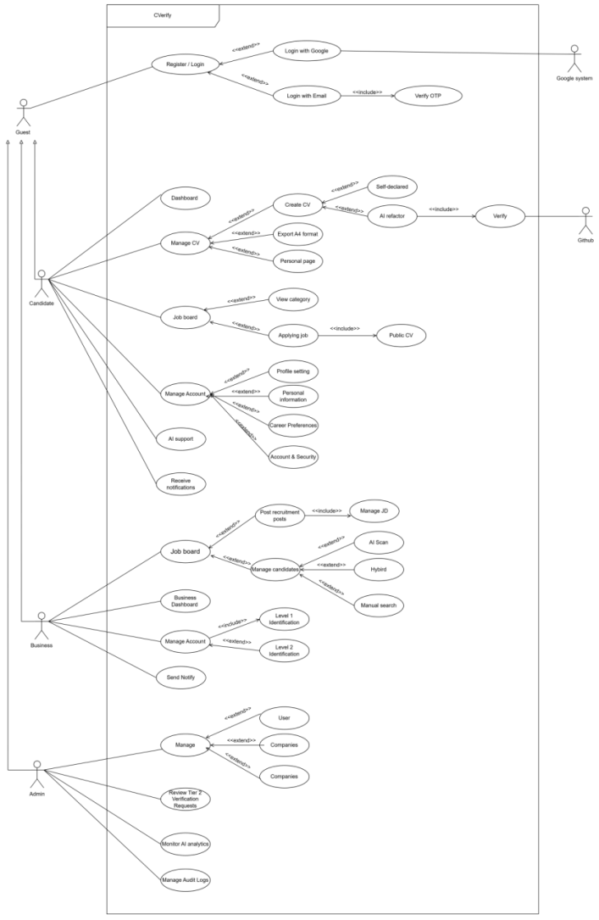

4.3.2 Login 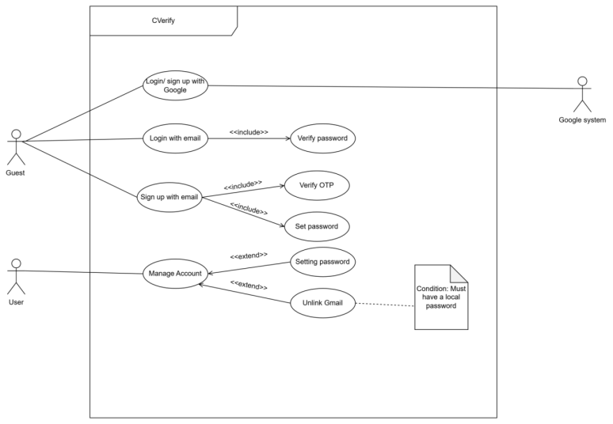

4.3.3 Authentication & Onboarding Flows

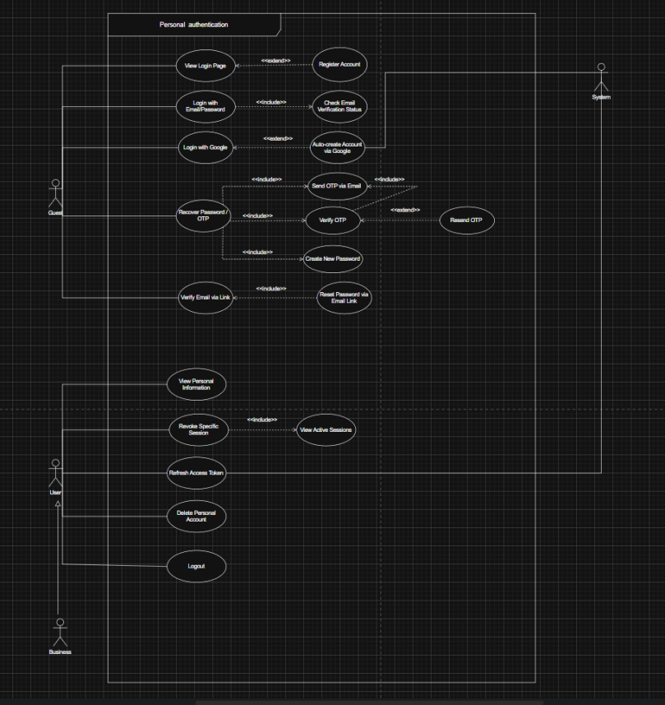

4.3.4 Business Onboarding
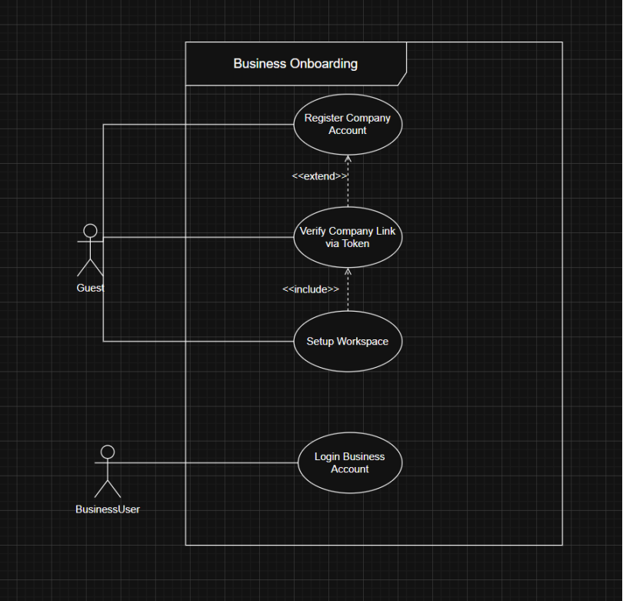

4.3.5 AI Flow
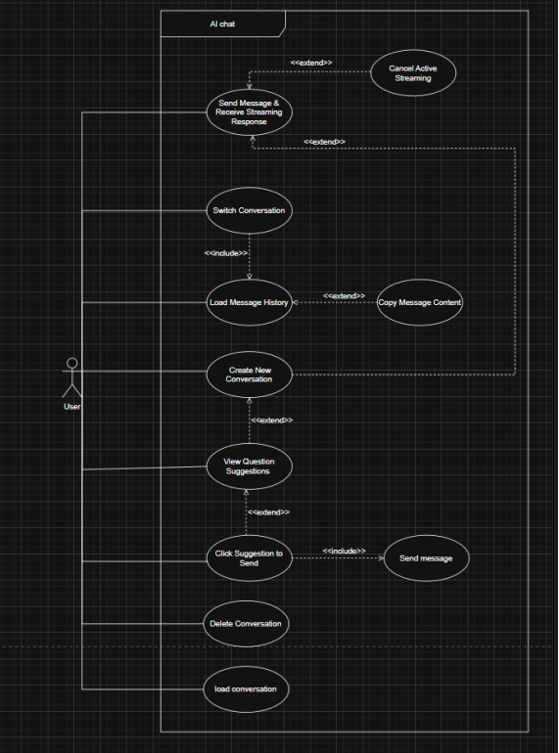

4.3.6 Admin dashboard
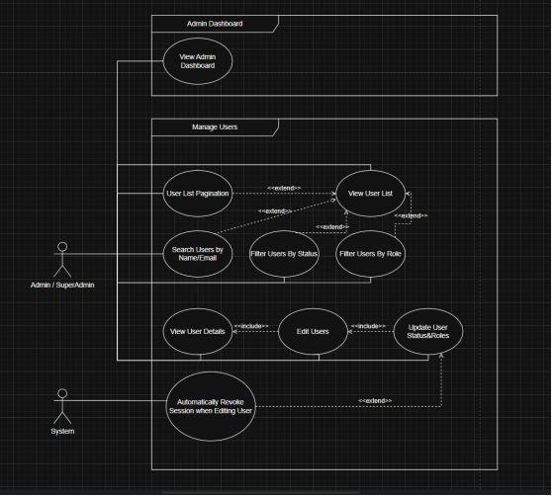

4.3.5 System Monitoring
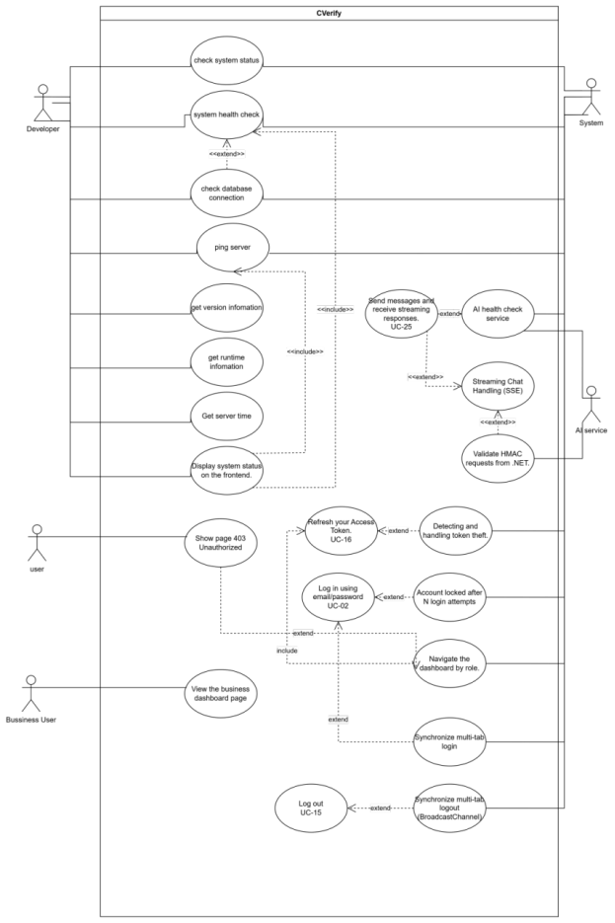

5. PRODUCT SCOPE

5.1 Context Diagram – System Overview
CVerify operates as a centralized, AI-driven intelligence layer that orchestrates data flow between engineering candidates, HR professionals, and multiple external service providers. To achieve its primary objective of evidence-based verification, the system strictly defines its boundaries and interacts with the following external interfaces:
External System | Interaction Direction | Integration Purpose & System Behavior
GitHub REST / GraphQL API | CVerify -> GitHub | Serves as the primary source of truth for candidate Proof-of-Work (PoW). The system queries repository metadata, commit histories, contributor statistics, and code diffs using a hybrid approach (GraphQL for bulk metadata, REST for selective file sampling) to optimize API rate limits.
GitHub Webhooks | GitHub -> CVerify | Enables event-driven Incremental Analysis. Instead of re-analyzing entire repositories, push events trigger the system to analyze only new commits (L2+ complexity), drastically optimizing LLM token costs.
Google OAuth 3.0 | CVerify <- Google | Provides secure, seamless social authentication for candidate and recruiter onboarding, mapping Google IDs to internal JWT sessions.
OpenAI API (GPT-4.1) | CVerify -> OpenAI | Utilized for structured extraction tasks (via Function Calling), semantic Gap Analysis, and generating 1536-dimensional embeddings (using text-embedding-3-large) for the candidate and job vectors.
Anthropic Claude API | CVerify -> Anthropic | Selected for its superior complex reasoning capabilities and large context windows. Claude Sonnet 4 is tasked with inferring the Hierarchical Skill Tree and executing semantic verification on ambiguous code evidence.
Google Gemini API | CVerify -> Google AI | Deployed for high-throughput, cost-efficient tasks such as generating repository descriptions and summarizing large volumes of code chunks.
Vietnam Tax API (MST) | CVerify -> esgoo.net/VietQR | Automates the Tier 1 Enterprise verification process by cross-referencing provided Company Names and Tax Codes (MST) with the national registry, ensuring platform integrity.
SMTP Email Provider | CVerify -> Email Server | Handles asynchronous dispatching of One-Time Passwords (OTPs), system notifications, and daily AI Digest emails.

5.2 System Architecture Overview
To guarantee high availability, support sub-10ms semantic searches, and seamlessly route tasks to multiple AI providers, CVerify is designed utilizing a highly decoupled, 5-Tier Layered Architecture.

Tier 1: Presentation Layer (Client)
- Technologies: Next.js 16 (App Router), HeroUI v3, Tailwind CSS v4.
- Functionality: Delivers a responsive, mobile-first Progressive Web App (PWA). This layer handles the real-time rendering of AI-generated streaming content via Server-Sent Events (SSE) and manages WebSocket connections (SignalR) for instantaneous pipeline notifications.

Tier 2: API Gateway & Security Layer
- Technologies: ASP.NET Core v10, JWT Authentication, FluentValidation.
- Functionality: Acts as the primary entry point for all client requests. It enforces strict Role-Based Access Control (RBAC), validates all inbound payloads to mitigate injection attacks, and routes authorized traffic to the underlying domain services.

Tier 3: Core Business Logic & Orchestration
- Technologies: .NET Domain Services, Credit Engine, Trust Score Calculator, Hangfire.
- Functionality: Encapsulates the core recruitment and evaluation logic. It calculates the multi-dimensional Trust Scores, manages the Active Window Credit anti-harvesting limits, and utilizes Hangfire for resilient, asynchronous background job processing (e.g., repository syncing and ATS score recalculations).

Tier 4: AI Orchestration Layer (Multi-Model Router)
- Technologies: Python, FastMCP (Model Context Protocol), GPT-4.1 / Claude Sonnet 4 / Gemini 2.5 Flash.
- Functionality: Functions as an intelligent MCP server that dynamically routes analytical tasks to the most cost-effective and capable LLM. It enforces a Circuit-Breaker Policy: if a primary model fails three consecutive times within 60 seconds, traffic is automatically routed to a designated fallback model to prevent service disruption.

Tier 5: Data Persistence & Semantic Storage Layer
- Technologies: PostgreSQL 16 + pgvector, Redis.
- Functionality:
  - PostgreSQL: Serves as the primary relational database holding user profiles, job posts, and an initial JSONB-based schema designed for future migration to a native Neo4j Knowledge Graph.
  - pgvector (HNSW): Stores the 1536-dimensional vectors for resumes and job descriptions, enabling approximate nearest-neighbor semantic matching at extreme speeds.
  - Redis: Functions dually as a distributed session cache and a Semantic Cache, intercepting duplicate AI queries (with a cosine similarity > 0.95) to significantly reduce external LLM API token consumption

6. OVERALL SYSTEM DESCRIPTION

6.1 Product Perspective
CVerify is a greenfield, standalone Software-as-a-Service (SaaS) web platform. It does not inherit from, nor does it extend, any legacy Applicant Tracking Systems (ATS) or existing HR software infrastructures. It operates as an independent, dual-sided marketplace connecting technical candidates with enterprise recruiters.
While CVerify is a self-contained application accessed via a web browser, it functions as a central intelligence hub that is deeply tethered to external ecosystems. It relies heavily on seamless integrations with Identity Providers (e.g., Google OAuth) and Version Control Systems (e.g., GitHub/GitLab) to ingest the raw technical data required for its Evidence-Based Scoring Engine.

6.2 Operating Environment
The platform is designed to be highly scalable, utilizing containerized microservices to handle the compute-heavy demands of AI orchestration and repository parsing.
Environment / Component | Minimum Specification | Operational Notes
Development | Local Docker Compose (4 vCPU, 8 GB RAM) | Runs lightweight versions of PostgreSQL + pgvector, Redis, the ASP.NET Backend, and Next.js Frontend for local testing.
Staging | Single VPS / EC2 t3.medium (2 vCPU, 4 GB RAM) | Mirrors the production architecture at a reduced scale to validate API integrations and UI behaviors.
Production (Core Services) | AWS ECS / Azure Container Apps (4 vCPU, 8 GB RAM min) | Employs auto-scaling rules based on Hangfire queue depths to manage sudden spikes in user activity or AI scanning requests.
Analysis Workers (Isolated) | Containerized Pods with tmpfs | Dedicated, isolated workers for executing Git clones and AST parsing. Storage is strictly limited to temporary memory (tmpfs) to ensure raw source code is never persistently stored.
Database | AWS RDS PostgreSQL 16 + pgvector (db.t3.medium, 100 GB SSD) | Configured for Multi-AZ high availability. Houses both relational business data and high-dimensional semantic vectors.
Cache & Message Broker | AWS ElastiCache Redis (cache.t3.micro) | Functions as a distributed session store, job queue broker, and a Semantic Cache to optimize LLM API calls.
Frontend CDN | Vercel (Pro Plan) | Hosts the Next.js application, leveraging edge functions and automatic global scaling for optimal latency.
Client Interface | Modern Web Browsers (Chrome 120+, Safari 17+) | Delivered as a mobile-first Progressive Web App (PWA); no native mobile application installation is required.

6.3 Design and Implementation Constraints
To ensure platform security, legal compliance, and economic viability, the development team MUST adhere to the following hard constraints:
- Approved Technology Stack: The system SHALL exclusively utilize Next.js 16 (Frontend), ASP.NET Core v10 (Backend API), PostgreSQL 16 + pgvector (Database), and Redis (Caching).
- Centralized AI Routing: All outbound calls to LLM providers SHALL be routed exclusively through the internal Multi-Model Router. Individual system components are strictly prohibited from calling AI provider APIs directly to ensure circuit-breaker policies are enforced.
- Secrets Management: All API keys, database credentials, and OAuth secrets SHALL be stored securely in Azure Key Vault or AWS Secrets Manager. Committing any secrets to version control is strictly prohibited.
- Accessibility Compliance: The frontend user interface SHALL comply with WCAG 2.1 Level AA standards for all interactive elements, including dynamically streaming AI outputs.
- Data Privacy (PDPA): All candidate personal data processing SHALL strictly comply with Vietnam Decree 13/2023/ND-CP. Candidate contact information must remain hidden until transactional consent (via credit expenditure) is executed by the recruiter.
- Asynchronous Resilience: All long-running background jobs (e.g., repository syncing, email dispatch) SHALL use Hangfire with PostgreSQL acting as the persistent job queue to guarantee execution despite server restarts.
- Raw Code Retention Ban: The system SHALL NOT persistently store raw source code from cloned repositories. All code scanning and chunking must occur in temporary memory (tmpfs), retaining only extracted metadata and structural JSON representations.
- Token Budget Optimization: To prevent excessive LLM costs, the system SHALL enforce an Incremental Analysis Architecture. Only new commits meeting a predefined complexity threshold (L2+) shall trigger partial AI capability updates.

6.4 Assumptions and Dependencies

6.4.1 Assumptions
The successful operation of the CVerify platform assumes the following conditions hold true:
- External API Stability: The GitHub API remains stable and available 99% of the time, and the platform successfully secures a GitHub App rate limit of 15,000 requests per hour.
- Candidate Behavior: Target candidates possess GitHub/GitLab repositories (either public or connectable via OAuth) that accurately contain evidence of their technical capabilities.
- National Registry Availability: The Vietnam Tax API (via esgoo.net/VietQR) maintains sufficient uptime to facilitate the automated onboarding of Tier 1 enterprise users.
- LLM Service Level Agreements: The utilized AI providers (OpenAI, Anthropic, Google) maintain an SLA of 99.5% uptime, ensuring the Multi-Model Router can successfully execute fallback strategies.

6.4.2 Dependencies
The development, testing, and production deployment phases are directly dependent on the following external prerequisites:
- OAuth Application Approvals: The GitHub OAuth App and Google OAuth client credentials must be formally registered and configured prior to the commencement of Sprint 2.
- Active AI Billing Accounts: The system requires provisioned, funded API keys for OpenAI (specifically to access text-embedding-3-large), Anthropic (Claude Sonnet 4), and Google Gemini (Flash 2.5).
- Database Extensions: The deployment environment for PostgreSQL must explicitly support and have the pgvector extension installed prior to schema initialization.
- Webhook Infrastructure: The Incremental Analysis pipeline is strictly dependent on the successful delivery of push-event webhooks from GitHub/GitLab to the CVerify backend endpoints.
- Vulnerability Databases: The Dependency Analysis tools require uninterrupted access to the OSV.dev API to accurately detect Common Vulnerabilities and Exposures (CVEs) within candidate repositories.

7. FUNCTIONAL REQUIREMENTS OVERVIEW
This chapter provides a high-level taxonomy of all Functional Requirements (FR) governing the CVerify platform. To accommodate the advanced capabilities of the v2.0 architecture—specifically the transition from static code scanning to full Evidence-Based Talent Intelligence—the functional modules have been expanded into 12 core domains.
The table below summarizes these modules, their associated requirement ranges, the primary actors involved, and the designated implementation sprint.

7.1 Functional Modules Summary Table
Module | Core Capabilities & v2.0 Enhancements | FR Range | Roles Involved | Target Sprint
1. Authentication & Security | Multi-provider login (Google/Email), strict OTP verification, JWT session management, and RBAC enforcement. | FR-01 – FR-05 | Candidate, Recruiter, Admin | Sprint 1
2. Candidate Profile & CV Management | Structured 8-section CV editor, portfolio linking, privacy toggles, and server-side PDF generation. | FR-06 – FR-10 | Candidate | Sprint 1–2
3. Repository Ingestion & Intelligence | Deep GitHub/GitLab integration, AST-aware chunking, Diff-First analysis, and Incremental Analysis for token cost optimization. | FR-11 – FR-16 | Candidate, AI System | Sprint 2
4. Evidence-Based Evaluation & Trust Scoring | Calculation of the multi-dimensional Trust Score, Multi-Signal Ownership Detection (anti-fraud), and the "Best-of-All" anti-score-farming strategy. | FR-17 – FR-22 | Candidate, AI System | Sprint 3
5. Career Leveling & Tendency Detection | [New in v2.0] AI-driven classification of technical archetypes (e.g., Backend, DevOps) and evidence-based career level estimation (L1 to L5) independent of claimed experience. | FR-23 – FR-26 | AI System | Sprint 3
6. Enterprise Workspace Governance | Tier 1/Tier 2 corporate onboarding via National Tax API (MST), internal role delegation, and secure company document management. | FR-27 – FR-32 | Recruiter (Admin/Manager) | Sprint 1–2
7. Standardized JD Management | [New in v2.0] A strict, form-based Job Description creator utilizing an AI JD Generator to normalize required skills, seniority, and salary ranges. | FR-33 – FR-37 | Recruiter | Sprint 2
8. Job Search & Semantic Matching | pgvector-powered candidate-to-job semantic search, Gap Analysis generation, and the enhanced Salary-Aware Match Score formula. | FR-38 – FR-42 | Candidate, Recruiter | Sprint 3
9. Recruitment Pipeline (Manual & Hybrid) | Interactive Kanban applicant tracking (Applied -> Hired), handling both manual candidate submissions and proactive AI candidate suggestions (Hybrid Mode). | FR-43 – FR-48 | Recruiter | Sprint 2–3
10. Platform Monetization & Anti-Harvesting | Management of the Active Window Credit Model, enforcing strict contact-reveal hard caps to prevent recruiter data harvesting. | FR-49 – FR-54 | Candidate, Recruiter | Sprint 4
11. Administrator Moderation & Observability | Centralized dashboard for approving Tier 2 accounts, monitoring LLM token consumption, investigating fraud alerts, and managing system audit logs. | FR-55 – FR-59 | System Admin | Sprint 1, 4
12. Notification & Event Streaming | Multi-channel alert delivery (Email + In-App via SignalR), including interview invitations, application stage transitions, and Real-Time SSE AI streaming. | FR-60 – FR-63 | All Roles | Sprint 3–4

7.2 Key Architectural Shifts from v1.0 to v2.0
(This section highlights the critical functional updates introduced based on internal technical research to ensure all stakeholders are aligned).
- From Flat Scoring to "Best-of-All": Requirements in Module 4 (FR-17 to FR-22) have been updated to evaluate candidates based on their highest-performing repositories (MAX(Individual Repo Scores)) rather than an average, directly neutralizing repository spamming tactics.
- Standardization of Recruitment Data: Module 7 (FR-33 to FR-37) replaces free-text JD uploads with the Standardized JD System. This ensures that the AI Semantic Matching (Module 8) operates on normalized data, improving match accuracy by enforcing explicit salary and seniority boundaries.
- Code Evidence over Self-Declaration: Module 5 (FR-23 to FR-26) explicitly mandates that a candidate's Career Level (Junior to Principal) is evaluated strictly via code evidence (e.g., architectural commits, PR reviews) rather than relying on self-reported years of experience.

8. AUTHENTICATION AND AUTHORIZATION REQUIREMENTS

8.1 Authentication Requirements
The authentication layer governs how users establish their identity within the platform, supporting both standard credentials and modern social Single Sign-On (SSO).
ID | Requirement Specification | Priority | Target Sprint
FR-01 | The system SHALL allow Candidates to register via Email + OTP or Google OAuth 2.0. For email registration, the system SHALL send a 6-digit OTP with a strict Time-To-Live (TTL) of 15 minutes to verify ownership before account activation. | High | Sprint 1
FR-02 | The system SHALL allow Business entities to register a unified Workspace by providing a company email, company name, and Vietnamese Tax Code (MST). The MST SHALL be auto-verified via a national registry API to instantly provision a Tier 1 account. | High | Sprint 1
FR-03 | The system SHALL support hybrid identity linking. A candidate who initially registered via email MUST be able to link an additional Google account to the same profile seamlessly, with the backend automatically handling duplicate email detection and mapping to a single user profile. | High | Sprint 1
FR-04 | The system SHALL block registration attempts originating from known disposable email domains (e.g., temp-mail, yopmail, mailinator) to protect platform integrity and prevent the creation of bot accounts. | High | Sprint 1
FR-05 | The system SHALL enforce an anti-enumeration policy during the "Forgot Password" and Registration flows. The system MUST consistently return a generic "OTP Sent" response regardless of whether the email exists in the database, preventing attackers from harvesting registered emails. | High | Sprint 1

8.2 Authorization and RBAC Requirements
Authorization in CVerify is divided into Global System Roles and granular Business Workspace Roles.
ID | Requirement Specification | Priority | Target Sprint
FR-06 | The system SHALL implement robust Role-Based Access Control (RBAC). Global roles SHALL include: Job_Seeker, System_Admin, and Business_User. | High | Sprint 1
FR-07 | Within a Business Workspace, the system SHALL enforce predefined internal roles. These MUST include: COMPANY_ADMIN (full control, billing, member management), COMPANY_MANAGER (JD creation, candidate management), RECRUITER (limited to processing candidates for assigned JDs), and VIEWER (read-only access to pipelines). | High | Sprint 1
FR-08 | The COMPANY_ADMIN SHALL have the capability to create Custom Roles by selecting specific permissions from a granular Permission Matrix (e.g., CREATE_JD, VIEW_CANDIDATE, EDIT_COMPANY_INFO) and assign them to workspace members. | Medium | Sprint 2

8.3 Session and Security Management Requirements
To ensure continuous protection of user sessions, the platform utilizes strict JWT practices and multi-factor authentication.
ID | Requirement Specification | Priority | Target Sprint
FR-09 | The system SHALL implement stateless authentication utilizing JSON Web Tokens (JWT). The short-lived Access Token (15-minute TTL) SHALL be stored securely in client memory, while the Refresh Token (7-day TTL) SHALL be stored in an HttpOnly, Secure, SameSite=Strict cookie to prevent Cross-Site Scripting (XSS) extraction. | High | Sprint 1
FR-10 | Refresh Token Rotation SHALL be strictly enforced. Every usage of a Refresh Token MUST issue a new token pair and instantly invalidate the previous Refresh Token to detect and mitigate token theft. | High | Sprint 1
FR-11 | The system SHALL implement Brute-Force Protection. Upon 5 consecutive failed login or OTP attempts, the user's IP and account SHALL be temporarily locked out for a 15-minute cooldown period. | High | Sprint 1
FR-12 | Candidates and Business Users SHALL have the ability to enable Two-Factor Authentication (2FA) via Time-based One-Time Passwords (TOTP) using standard authenticator applications (e.g., Google Authenticator, Authy). | Medium | Sprint 4
FR-13 | Users SHALL be able to view their active login sessions (device, IP, location) and execute a "Logout from All Devices" command. This action MUST immediately revoke all active Refresh Tokens in the database, forcing immediate re-authentication across all endpoints. | High | Sprint 4

8.4 Detailed Requirement Specifications

8.4.1 Detailed Requirement Sample – FR-01: Candidate Registration
Attribute | Detail
Requirement ID | FR-01
Priority | High
Req. Name | Secure Candidate Account Registration
Actor | Candidate (Guest / Unauthenticated User)
Description | The system SHALL allow a Candidate to register a new account utilizing either an email address (protected by OTP) or Google OAuth 2.0. Email addresses MUST be normalized and verified via a 6-digit OTP before the candidate profile is officially activated and initialized.
Preconditions | - The user does not possess an active CVerify account.  - The user has navigated to the /register route.  - The email domain is not present on the disposable email blocklist.
Main Flow | - The user selects a registration method (Email or Google).  - If Email: The user inputs their email and establishes a password. The system validates password strength (min 8 chars, 1 uppercase, 1 number, 1 special character).  - The backend normalizes the email (lowercasing, removing Gmail . and + aliases) and generates a 6-digit OTP.  - The user inputs the OTP received via email.  - The backend verifies the OTP and activates the account.  - If Google: The system initiates the Google OAuth consent flow, extracts the email and sub ID upon success, and auto-verifies the account.
Alternative Flow | AF-01 (Duplicate Account): If the normalized email already exists during the Email flow, the system intentionally returns the standard "OTP Sent" message (Anti-enumeration rule) but does not actually send a registration OTP.  AF-02 (OTP Expiration): If the OTP TTL (15 minutes) expires, the user is prompted to request a new OTP subject to a 60-second cooldown period.
Postconditions | A new user record is persisted with role = job_seeker and email_verified = true. A corresponding candidate_profile database entity is initialized. The user is issued a JWT session and redirected to the Candidate Dashboard.

8.4.2 Detailed Requirement Sample – FR-07: Internal Workspace RBAC
Attribute | Detail
Requirement ID | FR-07
Priority | High
Req. Name | Business Workspace Role Assignment & Validation
Actor | Company Admin (COMPANY_ADMIN)
Description | The system SHALL restrict access to corporate Job Descriptions, candidate pipelines, and financial billing based on internal workspace roles assigned to invited members.
Preconditions | - The workspace has been successfully initialized (Tier 1 or Tier 2).  - The acting user holds the COMPANY_ADMIN role within that specific workspace context.
Main Flow | - The COMPANY_ADMIN navigates to Workspace Settings -> Members.  - The admin selects an existing member or invites a new email.  - The admin assigns one of the predefined system roles: COMPANY_MANAGER, RECRUITER, or VIEWER.  - The backend updates the WorkspaceMember entity and immediately invalidates the affected user's permission cache in Redis.
Business Rules | - A RECRUITER CANNOT publish a JD; their drafts MUST be transitioned to PendingApproval for a COMPANY_MANAGER to review.  - A RECRUITER CAN ONLY view candidates applying to JDs explicitly assigned to them.
Postconditions | The member's access token scopes are updated upon their next request. Unauthorized attempts to modify JDs or view unassigned pipelines will strictly return an HTTP 403 Forbidden response.

9. CANDIDATE MODULE REQUIREMENTS

9.1 Profile Management
These requirements govern the structured data entry and visibility controls of a candidate's profile.
ID | Requirement Specification | Priority | Sprint
FR-06 | The system SHALL provide a structured CV editor supporting: Personal Info, Education, Work Experience, Skills (self-declared), and Projects (manually added). All inputs SHALL undergo real-time validation. | High | Sprint 2
FR-07 | The system SHALL utilize an Evidence Badge System: Manually added projects SHALL display a 'Self-declared' (yellow) badge, while projects validated via the AI Pipeline SHALL display a 'Verified' (green) badge. | High | Sprint 2
FR-08 | The system SHALL provide a CV Parsing engine that accepts PDF/DOCX (max 5 MB). The AI SHALL use layout-aware parsing (Stage 1) and LLM-based NER (Stage 2) to automatically map extracted entities into the structured CV editor. | High | Sprint 2
FR-09 | Candidates SHALL manage Career Preferences, including expected salary, preferred work model (Remote/Hybrid/Onsite), and desired seniority levels. | Medium | Sprint 2
FR-10 | Candidates SHALL control visibility_mode: Hidden (profile inactive), Passive (discoverable via keyword search only), and Active (AI auto-recommendation enabled via credit-based access). | High | Sprint 4

9.2 GitHub/GitLab Repository Integration
These requirements govern the ingestion and analysis of technical evidence. The system MUST implement the Hybrid 2-Phase Ingestion to balance API efficiency and analysis depth.
ID | Requirement Specification | Priority | Sprint
FR-11 | The system SHALL facilitate repository linking via OAuth 2.0. The ingestion engine SHALL utilize a Hybrid 2-Phase Ingestion: Phase 1 (GraphQL API) for metadata and stats; Phase 2 (Selective Shallow Clone) for file-tree analysis. | High | Sprint 2
FR-12 | Each repository analysis SHALL perform Contribution Ownership Detection. The system SHALL calculate an Ownership_Score for the candidate by analyzing commit authorship, PR participation, and git blame samples to isolate their actual work from forked/AI-generated boilerplate. | High | Sprint 2
FR-13 | Candidates SHALL toggle individual repository visibility (Public/Private on CVerify profile). Note: Private visibility on CVerify does not affect the repository's status on GitHub. | High | Sprint 2
FR-14 | The system SHALL use AI Function Calling to generate repository descriptions in strict JSON Schema. The AI MUST prioritize the README.md, package.json/pom.xml, and core entry points, while ignoring auto-generated files (e.g., dist/, build/). | High | Sprint 2
FR-15 | Repository insights SHALL be streamed to the frontend via SSE. Candidates SHALL have the right to edit AI-generated descriptions to rectify potential hallucinations before confirming. | High | Sprint 2

9.3 AI Skill Analysis & Scoring
These requirements detail the extraction of competencies, the generation of the Skill Tree, and the enforcement of the Best-of-All Scoring Strategy to ensure the platform remains resistant to score-farming.
ID | Requirement Specification | Priority | Sprint
FR-16 | The system SHALL generate a hierarchical Skill Tree (Category -> Technology -> Sub-skill). Each node MUST denote the evidence source: Verified (code artifacts) or Self-declared (resume only). | High | Sprint 3
FR-17 | The Skill Tree SHALL be converted into a 1536-dimensional vector embedding (using text-embedding-3-large) and indexed via pgvector HNSW for semantic retrieval. | High | Sprint 3
FR-18 | The system SHALL calculate a Trust Score (0–100) utilizing the Best-of-All Strategy. The final score SHALL be determined by the MAX(Individual Repo Scores) to prevent "score farming" via numerous low-quality repositories. | High | Sprint 4
FR-19 | The AI Pipeline SHALL detect and flag fraudulent repo patterns. Repositories identified as 'Forked – Low Originality', 'Unusual Activity Pattern', or 'Boilerplate' SHALL be automatically excluded from the ATS score calculation. | High | Sprint 4
FR-20 | The system SHALL perform Real-time AI Gap Analysis. Upon viewing a JD, the AI SHALL compare the candidate's Skill Tree against JD requirements, highlighting Matched Skills, Missing Skills, and a recommended learning path streamed in real-time. | High | Sprint 3

9.4 Business Rules for Candidate Integrity
- [BR-13] Best-of-All Scoring Integrity: To prevent candidate manipulation, the system SHALL NOT sum up scores across all repositories. It SHALL evaluate the best-performing repository evidence and only factor in cross-repo contributions that meet the Ownership_Score threshold ($\ge$ 30%).
- [BR-14] Complexity Gating: Commits classified as L1 (Trivial — e.g., formatting, typo fixes) in the Complexity Taxonomy SHALL NOT contribute significantly to the candidate's Power Score. Only L2 through L6 technical commits SHALL drive the skill assessment model.
- [BR-15] Multi-Signal Validation: A skill shall only receive a 'Verified' (green) badge if both the manifest file (e.g., package.json) AND at least 3 source files contain patterns matching that skill, effectively preventing false positives from repository cloning.

10. RECRUITER AND COMPANY MODULE REQUIREMENTS

10.1 Company Onboarding & Governance
These requirements ensure that CVerify maintains a verified, high-trust environment for enterprise users.
ID | Requirement Specification | Priority | Sprint
FR-36 | The system SHALL auto-verify Tier 1 company registration via the Vietnam Tax API (esgoo.net/VietQR). If APIs are unreachable, the system MUST automatically queue the registration for manual Admin review to prevent onboarding delays. | High | Sprint 1
FR-37 | To upgrade to Tier 2, the system SHALL require: (1) Legal Representative Name + 12-digit CCCD, (2) Scanned Business License ($\le$ 10 MB), and (3) OTP-verified phone number. | High | Sprint 1
FR-38 | The Admin Tier 2 review checklist SHALL integrate EXIF Metadata Integrity Checks on all uploaded legal documents to ensure the authenticity and origin of the submission. | High | Sprint 1

10.2 Job Description (JD) Management
CVerify v2.0 introduces the Standardized JD System to normalize requirements and improve the accuracy of AI semantic matching.
ID | Requirement Specification | Priority | Sprint
FR-39 | Companies SHALL create JDs utilizing the standardized input form (Title, Salary Range, Seniority, Tech Stack, Key Responsibilities). The AI SHALL automatically generate a structured JD description to ensure formatting consistency. | High | Sprint 2
FR-40 | Upon submission, the AI pipeline SHALL trigger: (1) Structured Requirement Extraction via LLM, (2) embedding generation (text-embedding-3-large), and (3) storage in the jd_embeddings vector store for HNSW matching. | High | Sprint 3
FR-41 | The system SHALL enforce an Application Quality Gate. If a candidate's profile lacks >50% of the 'Must-Have' skills defined in the JD, the system SHALL display a gap analysis warning to the candidate before submission. | Medium | Sprint 3

10.3 Manual Recruitment (Tier 1)
These requirements support standard recruitment workflows while maintaining platform transparency.
ID | Requirement Specification | Priority | Sprint
FR-42 | Tier 1 companies SHALL utilize a configurable recruitment Kanban pipeline (Pending -> Reviewing -> Interview -> Accepted/Rejected). | High | Sprint 2
FR-43 | Recruiters SHALL view the Candidate's Skill Tree and Proof-of-Work indicators (e.g., repository complexity scores, Trust Score). | High | Sprint 2
FR-44 | Recruiters SHALL be able to shortlist candidates (costs 3 credits). Shortlisted candidates SHALL appear in a dedicated dashboard view. | High | Sprint 3
FR-45 | Recruiters SHALL be able to reveal candidate contact information (costs 30 credits). This action MUST be gated by a hard cap of 5 reveals per organization per day (not per user) to deter mass data harvesting. | High | Sprint 4

10.4 AI-Powered Recruitment (Tier 2)
Tier 2 companies unlock the full power of the CVerify Intelligence Engine, including salary-aware matching and explainability reports.
ID | Requirement Specification | Priority | Sprint
FR-46 | For Tier 2 JDs, the system SHALL automatically scan the Active Candidate Pool using HNSW vector search to return candidates with an ATS score 75%. | High | Sprint 3
FR-47 | Salary-Aware Matching: The AI SHALL incorporate salary requirements into the ATS Score. Applications where the candidate's desired salary exceeds the JD's maximum range SHALL be flagged with a 'Salary Mismatch' warning. | High | Sprint 3
FR-48 | Tier 2 recruiters SHALL be able to adjust the weight of the 8 ATS factors (e.g., Skills, Experience, Contribution, Salary) in real-time. The ATS Score and Explainability Report MUST recalculate instantly. | Medium | Sprint 4
FR-49 | The system SHALL generate an Explainability Report for all AI-ranked candidates, providing a structured breakdown of why the candidate was ranked highly, specifically citing strong and weak dimensions. | High | Sprint 4
FR-50 | The system SHALL deliver a daily AI Digest email summarizing the Top-5 new candidate matches, optimized for daily recruiter engagement. | Medium | Sprint 4

10.5 Business Rules for Recruiter/Company Module
- [BR-16] Workspace-Level Anti-Harvesting: The hard cap of 5 contact reveals per day SHALL be enforced at the organization_id level, ensuring that even companies with multiple recruiter accounts cannot circumvent data harvesting protections.
- [BR-17] Verification-Based Publication: Only organizations with verificationStatus = 'Verified' (Tier 1 or Tier 2) SHALL be permitted to publish JDs to the public Job Board.
- [BR-18] Transparency in ATS Scoring: Recruiters MUST NOT hide the rationale behind a ranking. The Explainability Report generated by the AI MUST be accessible to both the recruiter and, at the company's discretion, the candidate (for gap analysis).

11. AI MODULE REQUIREMENTS

11.1 AI Architecture Overview
CVerify utilizes an AI-Native, Evidence-Based Pipeline. The architecture is structured into three distinct processing lines managed by a Multi-Model Router. This router dynamically selects between GPT-4.1 (OpenAI), Claude Sonnet 4.5 (Anthropic), and Gemini 2.5 Flash (Google) based on task-specific requirements for quality, latency, and cost-efficiency.

11.2 AI Model Routing & Optimization Strategy
AI Task | Primary Model | Fallback Model | Selection Rationale
JD Analysis & Extraction | GPT-4.1 (Function Calling) | Claude Sonnet 4.5 | Precision in structured JSON/schema output.
Repo Description Gen | Gemini 2.5 Flash | GPT-4.1 mini | High throughput, low cost, smooth SSE streaming.
Skill Tree Inference | Claude Sonnet 4.5 | GPT-4.1 | superior complex reasoning with 200k context window.
Semantic Embedding | text-embedding-3-large | Gemini embedding-005 | Native pgvector compatibility and high MTEB score.
Gap Analysis | GPT-4.1 | Claude Sonnet 4.5 | High-quality reasoning for career roadmapping.
Trust/Fraud Detection | Fine-tuned classifier | GPT-4.1 (few-shot) | Fast, deterministic pattern recognition.

11.3 AI Governance, Security & Feedback Loop
- [AI-14] Prompt Injection Defense: The system SHALL utilize an input sanitization layer (e.g., Guardrails AI) to neutralize adversarial attacks (e.g., instructions to ignore safety rules) in uploaded CVs, commit messages, or JD text.
- [AI-15] PII Redaction: The pipeline MUST automatically redact sensitive PII (e.g., phone numbers, home addresses, National IDs) before transmitting data to external providers.
- [AI-16] Human-in-the-Loop Feedback: The system SHALL provide a recruiter feedback mechanism (Thumbs Up/Down) for AI-suggested candidates. This feedback MUST be logged into ai_usage_logs to enable periodic model fine-tuning and performance drift monitoring.
- [AI-17] Cost/Token Budgeting: The system SHALL enforce an 'AI Token Budget' per workspace. If a workspace reaches 80% of its monthly token limit, the system SHALL alert the Admin and restrict non-essential AI features.

11.4 Pipeline 1: Repository Intelligence (Ingestion & Analysis)
- [AI-18] Hybrid 2-Phase Ingestion: The system SHALL utilize GraphQL for bulk metadata extraction and shallow Git cloning for selective file sampling to optimize API usage.
- [AI-19] AST-Aware Chunking: Code sent to the LLM MUST use AST-based chunking (e.g., Tree-sitter) to ensure logical boundaries (functions/classes) are preserved, preventing hallucination caused by arbitrary line-splitting.
- [AI-20] Multi-Signal Ownership Detection: The system SHALL calculate an Ownership_Score by triangulating git blame, PR participation, and clone detection (SimHash) to identify actual technical authorship.
- [AI-21] Complexity Gating (L1 to L6): The system SHALL classify every commit. L1 (trivial) commits SHALL bypass LLM analysis to preserve token budget, while L2+ commits SHALL trigger capability updates.

11.5 Pipeline 2: Candidate Evaluation & Skill Tree
- [AI-22] Multi-Pass Skill Extraction: Skill extraction SHALL use a two-pass approach: Pass 1 (Deterministic/Heuristic) to identify candidates, Pass 2 (LLM Enrichment) to add confidence and reasoning. Skills claimed by the LLM without hard file evidence MUST have confidence scores < 0.3.
- [AI-23] Evidence-Based Career Leveling: The AI SHALL estimate career level (L1–L5) based on architectural evidence (e.g., pattern usage, system design capability) rather than job titles.
- [AI-24] Tendency Detection: The AI SHALL classify candidates into one of 9 technical archetypes (e.g., Backend Engineer, Platform Engineer) based on cluster patterns in their evidence graph.

11.6 Pipeline 3: Semantic JD Matching & Ranking
- [AI-25] Salary-Aware Matching: The AI SHALL compute a Match_Score incorporating salary expectations. Applications exceeding JD ranges SHALL be flagged with a 'Salary Mismatch' warning.
- [AI-26] Best-of-All Scoring Strategy: Final capability scores SHALL be calculated as MAX(Individual Repo Scores) across the candidate's portfolio to prevent score farming.
- [AI-27] Explainability Reporting: Every ATS ranking MUST include an AI-generated report citing specific evidence (e.g., "Candidate shows L3 Spring Boot expertise demonstrated in auth-service repo").

11.7 Pipeline 4

11.8 Constraints and Limitations
- Advisory Nature: AI output is advisory; it SHALL NOT make final hiring/rejection decisions.
- Circuit-Breaker Policy: If a primary model fails 3 consecutive times in 60s, the router switches to the fallback model and alerts the Admin dashboard.
- Semantic Cache: The Redis-based cache (cosine similarity > 0.95) SHALL be employed to eliminate redundant LLM API calls.
- XSS Mitigation: All AI-generated output SHALL be sanitized via DOMPurify before rendering.

12. ADMINISTRATOR MODULE REQUIREMENTS
The Administrator Module provides the System Admin with the necessary tooling to maintain platform integrity, audit user activity, and exert control over the autonomous AI pipelines.
ID | Requirement Specification | Priority | Sprint
FR-35 | The Admin dashboard SHALL display all pending Tier 2 upgrade requests with a structured checklist UI (MST match, document validity, identity integrity). Admin approval/rejection MUST require a mandatory justification field. | High | 1
FR-36 | Admin SHALL possess full User Management capabilities: view, deactivate, reactivate accounts, modify roles, and access full user activity histories. | High | 1
FR-37 | Admin SHALL possess full Company Management capabilities: verify/unverify organizations, deactivate workspace access, and view associated Job Description lists and activity logs. | High | 1
FR-38 | Admin SHALL be able to manage the platform's Skill Ontology: create, edit, and delete skill labels and tech stack categories to maintain taxonomy consistency. | Medium | 2
FR-39 | The Admin dashboard SHALL display comprehensive AI Usage Analytics: per-model token consumption, cost-per-request, semantic cache hit rates, and total real-time AI expenditure. | Medium | 4
FR-40 | Admin SHALL be able to dynamically configure AI model routing (e.g., swapping primary/fallback models, tuning circuit-breaker thresholds) via the dashboard without requiring code redeployment. | Medium | 4
FR-41 | The system SHALL surface Fraud Alerts to the Admin dashboard when Trust Score anomalies are detected (e.g., Trust Score drops below 40, or a 'honeypot' profile is viewed $\ge$ 5 times/week by a single recruiter). | High | 4
FR-42 | Admin SHALL visualize system-wide performance metrics: user count by role, weekly JD volume, application conversion rates, and total credit-based revenue. | Medium | 4
FR-43 | Admin SHALL have access to an immutable, append-only Audit Log: tracking all sensitive data access (profile views, contact reveals, AI search queries) with timestamps and actor identities. Logs MUST be retained for a minimum of 12 months. | High | 2
FR-44 | Admin SHALL be able to fulfill Data Deletion (GDPR/PDPA) requests. Deletion SHALL cascade across all associated tables, including candidate profiles, embeddings, and application history, within 72 hours. | High | 3
FR-45 | AI Model Override: Admin SHALL have the authority to force-switch an AI provider globally if outages, significant hallucination issues, or model bias are detected. | High | 4
FR-46 | Human-in-the-Loop Override: Admin SHALL have the authority to manually reset or adjust a candidate's 'Trust Score' if evidence confirms a false-positive fraud flagging. | High | 4

12.1 Administrative Security & Governance
- [BR-19] Audit Log Immutability: Audit logs created by FR-43 SHALL NOT be modifiable by any role, including System Admins. Any attempt to modify logs MUST trigger an immediate high-priority security alert.
- [BR-20] Segregation of Duties: An Admin account holding VERIFICATION_ADMIN privileges (approving Tier 2 companies) SHALL NOT simultaneously hold PAYMENT_ADMIN privileges (managing company billing), ensuring a separation of financial and operational governance.
- [BR-21] AI Override Logging: Any use of the AI Model Override (FR-45) or Trust Score Override (FR-46) MUST be explicitly logged in the system's Audit Log with the timestamp, the acting Admin's ID, and the explicit justification for the override.

12.2 Dashboard Usability
- UI-09 (Admin Checklist UI): The Tier 2 approval process (FR-35) SHALL be rendered as a structured checklist requiring Admin verification of each document/ID field before the 'Approve' button becomes enabled, preventing accidental approvals.
- UI-10 (Fraud Alert Notifications): Fraud alerts surfaced via FR-41 SHALL be delivered via the Admin Notification System, providing a 'Direct Link' to the suspicious activity log or candidate profile for rapid investigation.

13. SYSTEM OPERABILITY & DISASTER RECOVERY

13.1 Platform Observability & Monitoring
To maintain the 99.5% uptime SLA defined in NFR-13, the system implements a multi-layer observability strategy:
- [OP-01] Real-time Health Checks: The system SHALL expose an authenticated /health/live and /health/ready endpoint. Kubernetes/ECS liveness probes SHALL restart containers if these endpoints fail to respond within 3 seconds.
- [OP-02] AI Pipeline Monitoring: The Admin Dashboard SHALL provide a dedicated view for AI health, monitoring:
  - Latency Trends: P99 response time per AI provider.
  - Error Rates: Circuit-breaker trip counts for primary models.
  - Token Usage: Real-time consumption logs vs. workspace budget.
- [OP-03] Distributed Tracing: All inter-service communications (Next.js -> ASP.NET -> AI Microservice) SHALL carry a Correlation-ID header to allow end-to-end tracing via OpenTelemetry/Jaeger.

13.2 Data Backup & Recovery (Disaster Recovery)
Data integrity is critical, particularly for credit balances and recruitment pipeline states.
- [OP-04] Automated Backups: PostgreSQL SHALL execute continuous WAL (Write-Ahead Logging) archiving to S3. Point-in-Time Recovery (PITR) MUST be enabled to allow restoration to any second within the past 30 days.
- [OP-05] Recovery Time Objective (RTO): In the event of catastrophic database failure, the system SHALL be restored to a functional state (RTO) within 4 hours.
- [OP-06] Recovery Point Objective (RPO): The maximum data loss (RPO) allowed in a disaster scenario SHALL be 15 minutes of transactional data.
- [OP-07] Disaster Recovery Drill: The team SHALL conduct a simulated disaster recovery drill before the Sprint 4 deployment to validate the S3 restoration pipeline.

13.3 Incident Response Protocol
- [OP-08] Automated Alerting: High-priority incidents (e.g., API exhaustion, database high-load, AI provider failure) SHALL trigger PagerDuty or Slack notifications to the DevOps lead.
- [OP-09] Circuit-Breaker Auto-Switch: If the primary AI provider fails (3 consecutive errors), the system SHALL automatically enter "Degraded Mode" (using fallback models) and notify the Admin Dashboard immediately.
- [OP-10] Data Anonymization for Debugging: In the event of a production bug requiring code-level analysis, developers SHALL ONLY access production logs that have been scrubbed of PII (Candidate names/emails replaced with UUIDs).

13.4 Capacity Planning & Scaling
- [OP-11] Auto-Scaling Triggers: The ECS/Container Apps environment SHALL scale based on Hangfire queue depth and CPU utilization (target 70%). If queue depth exceeds 1000 pending tasks, new worker pods MUST auto-provision.
- [OP-12] Load Shedding: During extreme load, the system SHALL prioritize high-value user actions (e.g., Job Posting, Candidate Application) over non-essential background tasks (e.g., daily digest emails, repository metrics recalculation) to maintain platform core functionality.

14. EXTERNAL INTERFACE REQUIREMENTS

14.1 User Interface (UI) Requirements
- Design System & Responsiveness: The frontend SHALL be built with Next.js 16 (App Router), HeroUI v3, and Tailwind CSS v4 utilizing the OKLCH color space to ensure P3 gamut support. All interfaces SHALL follow a mobile-first responsive paradigm with defined CSS breakpoints (sm: 640px, md: 768px, lg: 1024px, xl: 1280px).
- AI Streaming UX: AI-generated content (e.g., Gap Analysis, Repository Descriptions) SHALL be rendered incrementally as Server-Sent Events (SSE) tokens arrive. The UI MUST provide a visible streaming state (e.g., pulsing cursor, typing animation) and allow users to abort the stream via an explicit "Cancel" control.
- Persistent Credit Monitoring: The Active Window credit balance SHALL be reflected persistently in the candidate’s navigation bar. Updates MUST be pushed in real-time via SignalR/WebSockets following credit consumption or expiry events.
- Secure Admin Administrative UI: The Admin dashboard SHALL provide a structured checklist UI for Tier 2 verification, enforcing strict access controls. Raw document uploads (business licenses, IDs) SHALL be viewable only through a transient, authenticated signed-URL proxy to prevent direct exposure of sensitive enterprise files.

14.2 Software Interfaces (Third-Party APIs)
The system integrates with various external services. Each integration MUST adhere to the following failure handling and security policies.
External System | Purpose | Protocol / Auth | Failure Handling Strategy
GitHub REST API v3 | Repo crawl, stats, history | GitHub App Token | Exponential backoff on 429; queue-based ingestion.
GitHub GraphQL API | Batch metadata fetch | GitHub App Token | Fallback to REST API if GraphQL queries fail.
GitHub Webhooks | Event-driven re-analysis | HMAC-SHA256 Secret | Re-sync job queued on next scheduled Hangfire run.
Google OAuth 2.0 | Social authentication | OIDC (aud, exp claim validation) | Fallback to email/OTP registration flow.
OpenAI API (GPT-4.1) | JD/Gap Analysis, Embeds | Bearer / Key Vault | Circuit breaker; rotate to Claude Sonnet after 3 consecutive failures.
Anthropic Claude API | Skill Tree & Reasoning | Bearer / Key Vault | Fallback to GPT-4.1 if inference timeouts occur.
Google Gemini API | Repository summarization | API Key / Secret Mgr | Fallback to GPT-4.1 mini.
esgoo.net/VietQR | Tier 1 MST verification | HTTPS GET | Cascade to secondary vendor; if all fail, queue for manual Admin review.
Data Interchange Formats: All RESTful APIs SHALL exchange data using application/json format with UTF-8 encoding. Large datasets (e.g., full repository exports) SHALL utilize application/x-ndjson (Newline Delimited JSON) to facilitate streaming and parsing performance.

14.3 Communication Interfaces
- Security Protocols: All client-server communication SHALL mandate HTTPS (TLS 1.3 minimum). The server MUST enforce HSTS (HTTP Strict Transport Security) headers to prevent protocol downgrade attacks.
- Streaming & Real-Time:
  - AI token streaming SHALL be delivered via SSE over HTTP/2, implementing Last-Event-ID for connection-interruption recovery.
  - Real-time notifications SHALL utilize ASP.NET Core SignalR with fallback to Long Polling for environments where WebSockets are restricted.
- Background Processing: The system SHALL utilize Hangfire with PostgreSQL as the backing store for all asynchronous tasks, ensuring atomicity and job persistence.
- Email Deliverability: Outbound correspondence SHALL be sent via authenticated SMTP/API protocols. All domains MUST maintain valid SPF, DKIM, and DMARC records to prevent spoofing and ensure high deliverability scores.
- Error Handling Policies:
  - All external API calls SHALL be wrapped in a policy that logs request/response metadata to the audit store without exposing sensitive tokens.
  - Interfaces MUST implement a global error handling middleware that maps external API errors (e.g., GitHub 403, OpenAI 503) into standardized internal platform error codes for better user feedback.

15. DATA REQUIREMENTS

15.1 Data Dictionary – Core Entities

15.1.1 users
Attribute | Content
Meaning | Primary identity table. Normalized email is the primary identity key.
Key Fields | id (UUID, PK), email (UNIQUE NOT NULL), email_verified (BOOL), role (ENUM: job_seeker/recruiter/admin), created_at, updated_at
Relationships | 1-1 with candidate_profiles, 1-N with auth_providers, N-1 with organizations
Security / Visibility Rules | Password hashed using BCrypt cost 12. PII fields encrypted at rest.

15.1.2 candidate_profiles
Attribute | Content
Meaning | Extended candidate profile with flexible CV data.
Key Fields | id, user_id (FK), cv_data (JSONB: education, experience, skills, projects), skill_labels (TEXT[]), trust_score (0-100), visibility_mode (hidden/passive/active), window_expires_at (TIMESTAMPTZ)
Relationships | 1-1 with users, 1-1 with cv_embeddings, 1-N with repositories, 1-N with applications
Security / Visibility Rules | visibility_mode determines discoverability. Contact info is hidden until the recruiter pays credits.

15.1.3 cv_embeddings
Attribute | Content
Meaning | Vector table for semantic candidate search with HNSW index.
Key Fields | id, candidate_id (FK), embedding (vector(1536)), model_version, created_at, last_synced_at
Relationships | 1-1 with candidate_profiles
Security / Visibility Rules | Only aggregate/similarity search is permitted; raw embeddings are not exposed.

15.1.4 repositories
Attribute | Content
Meaning | GitHub/GitLab repositories linked by candidates.
Key Fields | id, candidate_id (FK), github_repo_id, name, description (AI-generated), tech_stack (JSONB), contribution_level, complexity_score, trust_signals (JSONB), is_visible_on_profile (BOOL)
Relationships | N-1 with candidate_profiles
Security / Visibility Rules | is_visible_on_profile allows candidates to hide specific repositories.

15.1.5 organizations
Attribute | Content
Meaning | Company / recruiter entity table.
Key Fields | id, name, slug (UNIQUE), mst_code, verification_level (1 or 2), legal_docs (JSONB), subscription_plan, credit_balance
Relationships | 1-N with organization_members, 1-N with job_posts
Security / Visibility Rules | Legal documents are accessible to Admin only. MST code is not exposed publicly.

15.1.6 job_posts
Attribute | Content
Meaning | Job Descriptions posted by companies.
Key Fields | id, org_id (FK), title, jd_text (TEXT), jd_embedding (vector(1536)), tech_stack_tags, seniority, location, salary_range, status (active/paused/closed)
Relationships | N-1 with organizations, 1-N with applications
Security / Visibility Rules | jd_embedding is used for internal matching only.

15.1.7 applications
Attribute | Content
Meaning | Junction table between job_posts and candidate_profiles.
Key Fields | id, job_id (FK), candidate_id (FK), status (ENUM), ats_score (NUMERIC), ranking_factors (JSONB – 8 factors + weights), applied_at
Relationships | N-1 with job_posts, N-1 with candidate_profiles
Security / Visibility Rules | ranking_factors provides an audit trail for Explainability Reports.

15.1.8 audit_logs
Attribute | Content
Meaning | Immutable audit log for all data access events.
Key Fields | id, actor_id, actor_role, action (ENUM), target_entity, target_id, ip_address, user_agent, timestamp
Relationships | N-1 with users
Security / Visibility Rules | Immutable. Retained for a minimum of 12 months. Readable by Admin only.

15.1.9 notifications
Attribute | Content
Meaning | In-app and email notification records.
Key Fields | id, user_id (FK), type (ENUM), title, body (JSONB), is_read, delivery_channel (in-app/email/signalr), created_at
Relationships | N-1 with users
Security / Visibility Rules | Must not contain raw personal data of other users.

15.1.10 credit_transactions
Attribute | Content
Meaning | Credit transaction history (inflows and outflows).
Key Fields | id, org_id or candidate_id, type (debit/credit), amount, action (ENUM), balance_after, reference_id, created_at
Relationships | N-1 with organizations or candidate_profiles
Security / Visibility Rules | Immutable transaction log. Records may not be modified or deleted.

16. DATABASE REQUIREMENTS AND ERD

16.1 Logical Data Model – Entity Relationships
The CVerify database is designed for high-performance retrieval and semantic analysis, utilizing a relational structure for business logic and vector-graph hybrid storage for AI intelligence.
- Identity & Authentication: users (1) ──< (N) auth_providers: Each user profile maintains multiple authentication methods (Google, Email/Password, Passkey) for secure session management.
- Candidate Intelligence: users (1) ──── (1) candidate_profiles: One-to-one mapping for Job Seekers. candidate_profiles (1) ──── (1) cv_embeddings: Stores the 1536-dimensional vector representation for HNSW semantic search.
- Proof-of-Work Evidence: candidate_profiles (1) ──< (N) repositories: Links multiple GitHub/GitLab code repositories to a single candidate.
- Enterprise Structure: organizations (1) ──< (N) organization_members (Recruiters/HR staff) and job_posts.
- Recruitment Pipeline: job_posts (1) ──< (N) applications: Junction table containing the ranking_factors (JSONB) and ATS score metrics used for Explainability Reports.
- Knowledge Graph (Phase 3 Integration): The schema includes support for future migration to Neo4j, with explicit foreign keys connecting repositories, commit_signals, and capability_graph_nodes.

16.2 Vector Embedding & Semantic Search Architecture
The system utilizes pgvector with Hierarchical Navigable Small World (HNSW) indexing to satisfy the sub-10ms P99 latency requirements for semantic candidate-to-JD matching.
- Indexing Parameters: m=16 (max edges per node) and ef_construction=64 (size of dynamic list during index construction) provide an optimal recall rate of ~97%.
- Semantic Caching: A Redis Semantic Cache is implemented to intercept incoming AI queries. By calculating the cosine similarity between the current query and cached embeddings (threshold > 0.95), the system serves pre-computed AI insights, drastically reducing LLM token costs and latency.
- Bimodal Vector Search: The platform maintains two primary vector spaces: cv_embeddings (for searching candidates by job requirements) and jd_embeddings (for reverse JD matching against candidate skills).

16.3 Database Requirements
ID | Requirement Specification | Priority
DB-01 | PostgreSQL 16 with the pgvector extension SHALL be installed in all environments. HNSW indexes MUST be initialized on cv_embeddings.embedding and job_posts.jd_embedding. | High
DB-02 | All database interactions SHALL utilize parameterized queries via EF Core. Raw SQL string concatenation is strictly prohibited to prevent SQL injection vulnerabilities. | High
DB-03 | Connection pooling SHALL be enforced via Npgsql, with a min_pool_size=10 and max_pool_size=100 to manage high-concurrency AI pipeline requests. | High
DB-04 | Disaster Recovery: PostgreSQL SHALL execute continuous WAL (Write-Ahead Logging) archiving to S3. Point-in-Time Recovery (PITR) MUST be configured for a 30-day retention window. | High
DB-05 | The HNSW index SHALL support parallel index building to reduce background re-indexing time by approximately 60% during bulk data updates. | Medium
DB-06 | Atomic Transactions: All credit-based credit_transactions and status transitions in applications MUST be wrapped in ACID-compliant transactions to prevent data inconsistency during concurrent recruitment pipeline updates. | High

16.4 ERD Architecture
(Note: Refer to the provided architecture diagrams in the project appendix for the visual representation of these entity relationships.)
- Recruitment Pipeline ERD: Defines the lifecycle of a JOB_APPLICATION, tracking stages from APPLIED to HIRED or REJECTED, with a detailed ApplicationStageHistory ledger for auditability.
- Trust Intelligence ERD: Structures the TRUST_PROFILE, TRUST_SCORE_FACTOR (8-factor ATS score), and TRUST_EVIDENCE (links to specific code commits), ensuring the Explainability Report is grounded in immutable data.
- Verification Platform ERD: Governs the Tier 2 Company Onboarding process, linking ORGANIZATION to VERIFIED_CLAIM and VERIFICATION_EVIDENCE (scanned licenses/IDs) which are stored in secure, restricted-access object storage buckets.

16.4.1 AI Recruitment ERD
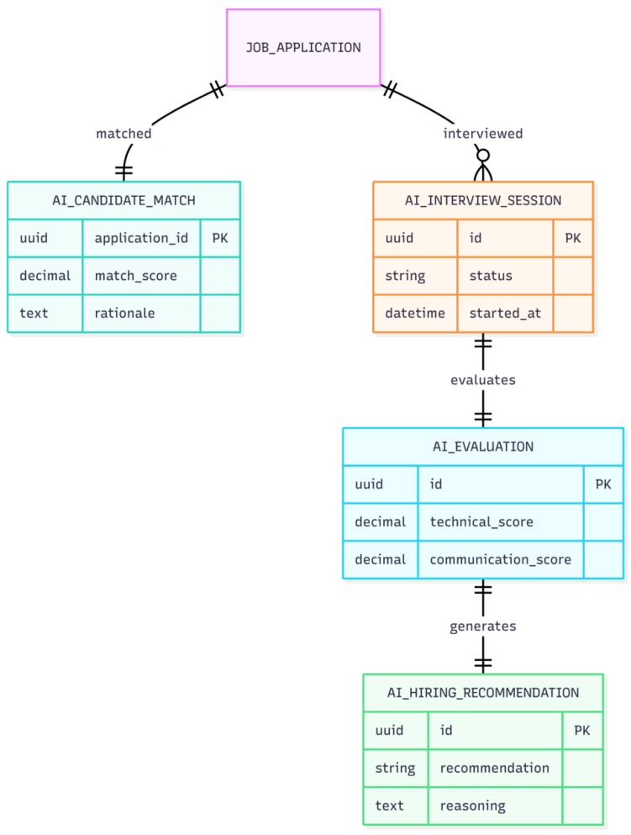

16.4.2 AI Recruitment ERD

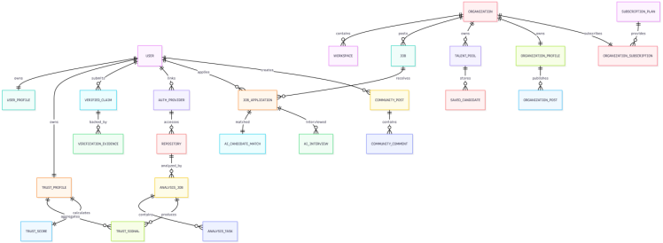16.4.3 :Master CVerify Platform ERD

16.4.4 Repository Intelligence ERD

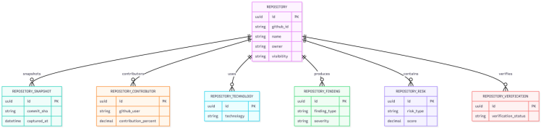

16.4.5 Trust Intelligence
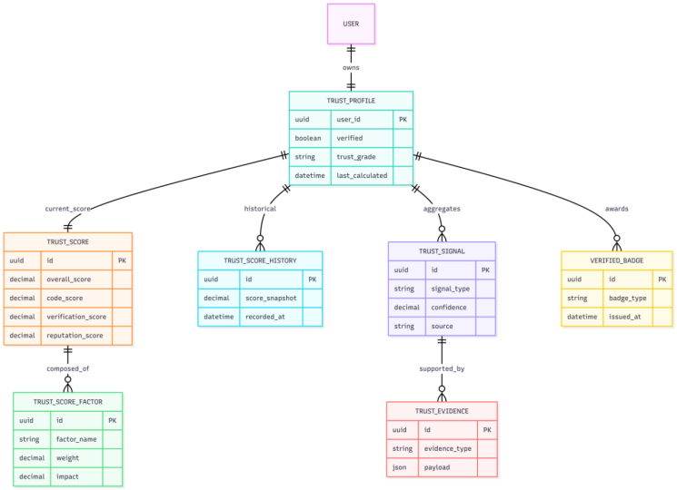

16.4.6 Verification Platform ERD
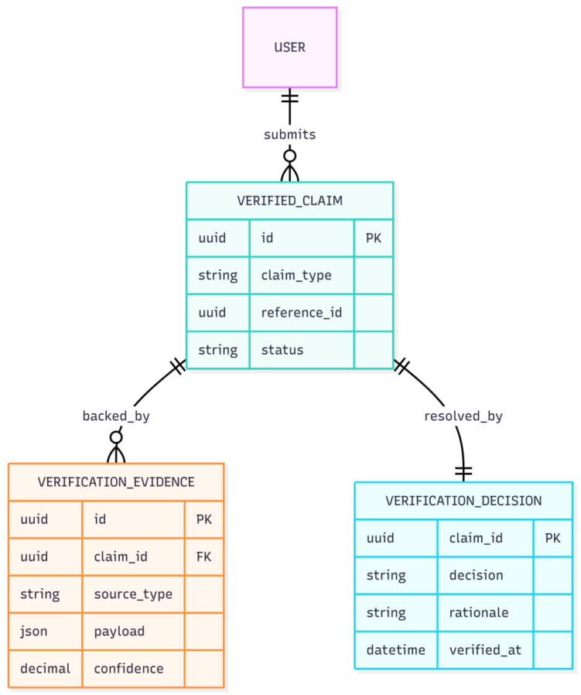

17. NON-FUNCTIONAL REQUIREMENTS

17.1 Performance Requirements
ID | Requirement | Metric / Target | Priority
NFR-01 | Core Web Vitals: LCP < 2.5s, FID < 100ms, CLS < 0.1 on the candidate and recruiter dashboards. | Google Lighthouse >= 90 | High
NFR-02 | Semantic candidate search queries SHALL respond within 200ms at P95 under a load of 500 concurrent users. | P95 <= 200ms @ 500 CU | High
NFR-03 | pgvector HNSW index queries SHALL complete in under 10ms P99 for a dataset of up to 1 million candidate vectors. | P99 <= 10ms @ 1M vectors | High
NFR-04 | SSE streaming token delivery from AI provider to frontend SHALL exhibit a UI update latency of less than 50ms per token. | UI update <= 50ms/token | Medium
NFR-05 | The initial JavaScript bundle size SHALL not exceed 250 KB (gzipped) for the critical path. Lazy loading SHALL be applied to all AI-feature modules. | Bundle <= 250 KB gzip | Medium
NFR-06 | Redis Semantic Cache SHALL achieve a minimum hit rate of 40% for AI calls within the first month of production operation. | Cache hit rate >= 40% | Medium

17.2 Security Requirements
ID | Requirement | Metric / Target | Priority
NFR-07 | All API endpoints accepting user input SHALL enforce FluentValidation rules. No raw user input SHALL reach the database layer without validation. | 0 unvalidated inputs | High
NFR-08 | All database queries involving user-supplied parameters SHALL use EF Core parameterized queries. Raw SQL string concatenation is prohibited. | 0 raw SQL with user input | High
NFR-09 | The system SHALL implement OWASP Top 10 mitigations including CSRF tokens (SameSite cookie), Content Security Policy headers, X-Frame-Options, and HSTS. | OWASP ZAP: 0 Critical findings on staging | High
NFR-10 | All API keys and secrets SHALL be stored in Azure Key Vault or AWS Secrets Manager. No secrets SHALL be committed to version control or appear in logs. | 0 secrets in code/logs | High
NFR-11 | Refresh token rotation SHALL be enforced: each use of a refresh token SHALL issue a new token and invalidate the old one. | Token rotation on every use | High
NFR-12 | AI-generated content displayed in the frontend SHALL be sanitized with DOMPurify before DOM insertion to prevent XSS via model output injection. | 0 XSS via AI content | High

17.3 Reliability and Availability
ID | Requirement | Metric / Target | Priority
NFR-13 | The production environment SHALL target 99.5% uptime (< 3.6 hours downtime per month), excluding scheduled maintenance windows. | Uptime >= 99.5% | High
NFR-14 | All Hangfire background jobs SHALL implement retry logic with exponential backoff (max 3 retries). Failed jobs SHALL be moved to a dead-letter queue and surfaced in the Admin dashboard. | Max 3 retries; dead-letter alert | High
NFR-15 | The AI Multi-model Router SHALL implement a circuit-breaker pattern: if a primary AI provider fails 3 consecutive times within a 60-second window, the router SHALL automatically switch to the configured fallback model. | Circuit breaker: 3 failures / 60s | High

17.4 Maintainability and Scalability
ID | Requirement | Metric / Target | Priority
NFR-16 | Unit test coverage SHALL achieve >= 80% line coverage for backend business logic and AI parsers (xUnit), and >= 80% for frontend utilities (Jest). | >= 80% line coverage | High
NFR-17 | Integration test coverage SHALL achieve >= 60% of API endpoints verified via xUnit + TestContainers. | >= 60% endpoint coverage | Medium
NFR-18 | The backend API tier SHALL support horizontal scaling via stateless JWT authentication and externalized session state in Redis. | Stateless API (0 server-side session) | High

17.5 Usability Requirements
ID | Requirement | Metric / Target | Priority
NFR-19 | The frontend SHALL comply with WCAG 2.1 Level AA for all interactive elements, including AI streaming output containers. | WCAG 2.1 AA  (automated + manual audit) | High
NFR-20 | All interactive elements SHALL be fully keyboard-navigable (Tab, Enter, Escape, Arrow keys). Focus indicators SHALL be visible and compliant with WCAG 2.1 SC 2.4.7. | Full keyboard coverage | High
NFR-21 | All text elements SHALL maintain a color contrast ratio of >= 4.5:1 for normal text and >= 3:1 for large text, consistent with WCAG 2.1 SC 1.4.3. | Contrast >= 4.5:1  (normal text) | High
NFR-22 | A new user (candidate) SHALL be able to complete the core onboarding flow (register → link GitHub → view Skill Tree) in <= 10 minutes. | Onboarding <= 10 minutes | Medium

17.6 Privacy and Compliance
ID | Requirement | Priority
NFR-23 | The system SHALL comply with Vietnam Decree 13/2023/ND-CP (PDPA). Candidate PII SHALL not be exposed to recruiters beyond what is permitted by the candidate's visibility settings. | High
NFR-24 | Contact information SHALL only be revealed to a recruiter after spending the designated credit amount (30c) – ensuring transactional consent for each data access event. | High
NFR-25 | Candidate data deletion requests SHALL be honored within 72 hours. Deletion SHALL cascade across all related tables. | High
NFR-26 | Candidate PII SHALL NOT be transferred outside Vietnam's jurisdiction unless required by DPA-covered AI providers. | High
NFR-27 | Invisible Unicode zero-width character watermarks unique to each recruiter-candidate pair SHALL be embedded in all exported profile text for forensic tracking in the event of a data leak. | Medium

18. BUSINESS RULES
ID | Business Rule | Applies To | Priority
BR-01 | A candidate may have only one profile on the system. Email is the primary identity key (normalized: lowercase, Gmail dot/plus aliases removed). | Candidate | High
BR-02 | Tier 2 access is granted only after Admin manually approves the legal documents. Review SLA: 1–2 business days. | Recruiter, Admin | High
BR-03 | An Active Window may only be purchased when the credit balance is sufficient. No credit may be borrowed. Auto-renewal deducts credits 24 hours before expiry. | Candidate | High
BR-04 | A recruiter may not be charged twice for revealing the contact information of the same candidate (idempotent; only charged once). | Recruiter | High
BR-05 | Hard cap: 5 contact reveals per recruiter account per day, regardless of credit balance. | Recruiter | High
BR-06 | Self-declared skills CANNOT be marked 'Verified' through candidate self-declaration alone. Only AI-verified skills from code evidence may receive a green badge. | Candidate | High
BR-07 | Recruiters may only view profiles of candidates with visibility_mode = 'passive' or 'active'. Hidden candidates do not appear in any search. | Recruiter | High
BR-08 | AI SHALL NOT automatically reject a candidate. The ATS Score is advisory only. The final decision rests with the recruiter. | All | High
BR-09 | A Trust Score below 40 SHALL trigger a fraud alert to the Admin and display a warning to any recruiter viewing the profile. | Candidate, Admin | High
BR-10 | All credit transactions must be logged immutably. credit_transactions records may not be modified or deleted. | All | High
BR-11 | If a company is deactivated by Admin, all of that company's JDs are automatically set to status = 'closed'. | Recruiter, Admin | Medium
BR-12 | When a candidate deletes their account, all their applications are anonymized rather than deleted, to preserve recruiter data integrity. | Candidate, Admin | High

19. UI/UX REQUIREMENTS AND PROTOTYPE

19.1 Design System
Component | Specification
UI Framework | Next.js 16 App Router + HeroUI v3 component library
Styling | Tailwind CSS v4 with OKLCH color space for P3 gamut support
Design Tokens | Standardized in tailwind.config: brand colors, spacing, typography
Icons | Heroicons (Tailwind) + Lucide React
Typography | Inter (headings) + JetBrains Mono (code snippets)
Responsive | Mobile-first with breakpoints: sm(640px), md(768px), lg(1024px), xl(1280px)
Dark Mode | Light/dark mode support via Tailwind dark: prefix

19.2 Key UI Requirements
ID | Requirement | Priority
UI-01 | The Skill Tree SHALL be rendered as a visual graph (node-link diagram). Each node displays the skill name, a proficiency bar, and an evidence badge (green = AI verified, yellow = self-declared). | High
UI-02 | AI streaming content SHALL have a visible streaming indicator. Users may cancel a running stream. | High
UI-03 | The repository list SHALL display: name, description (AI or user-edited), tech stack badges, complexity score (1–10), Trust Score indicator, and a visibility toggle. | High
UI-04 | The recruitment pipeline SHALL be rendered as a Kanban board: Pending | Reviewing | Interview | Accepted | Rejected. Drag-and-drop to change stage. | Medium
UI-05 | Gap Analysis SHALL be displayed in 3 columns: Matched Skills (green), Missing Skills (red), and Recommended Roadmap (yellow). | High
UI-06 | The ATS Score SHALL be displayed as a radar chart with 8 axes weighted by color, accompanied by a bar chart for each factor. | Medium
UI-07 | Candidate search results SHALL display a profile card: avatar, name (masked before reveal), ATS score badge, top 3 skills, and a Trust Score bar. | High
UI-08 | The credit balance SHALL always be visible in the navbar. A warning badge SHALL appear when the balance falls below 10 credits. | High

19.3 Prototype / Wireframe
Figma Link | Click Here
The prototype covers the following primary screens:
- Candidate: Register/Login, Profile Setup, Repository Linking, Skill Tree View, Job Search, Gap Analysis, Active Window Purchase.
- Recruiter: Company Onboarding, JD Creation, Candidate Search (Tier 1), AI Matching Dashboard (Tier 2), Pipeline Kanban, Profile View.
- Admin: Tier 2 Review Queue, User Management, Company Management, AI Analytics, Fraud Alerts, System Configuration.

19.4 Actual Implementation Screen Flow (Screenshots)
The screens below are captured directly from the current CVerify implementation and illustrate the end-to-end screen flow corresponding to the primary screens listed in Section 19.3, covering both the Candidate side (authentication and Digital Profile) and the Business/Recruiter side (Partner Console and Job Description management).

PART 1 — ENGINEER WORKFLOW (CANDIDATE)
Screen 1 & 3 — Login Page: The CVerify homepage. The "Engineer" tab supports Google OAuth or Email/OTP. The "Business" tab utilizes an Organization Slug and Password. Screen 3 represents the Dark Mode variant, maintaining full feature parity.
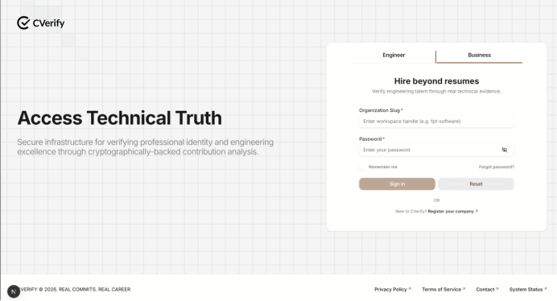
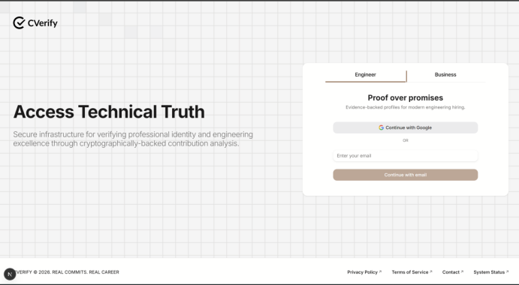
Screen 2 — Business Registration (3-Step Flow): Step 1: Legal Identity — Company name and Tax ID (MST) verification. Step 2: Owner/Representative Ownership validation. Step 3: Workspace Setup. Each step is strictly gated and unlocks sequentially upon completion of the previous phase.
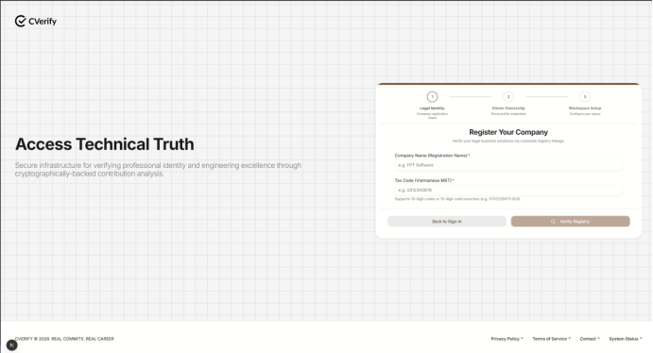

Screen 4 — Candidate Dashboard (Traveler Hub): The primary post-login interface. Displays account details, user roles, permission scopes, and the status of the Developer Sandbox.
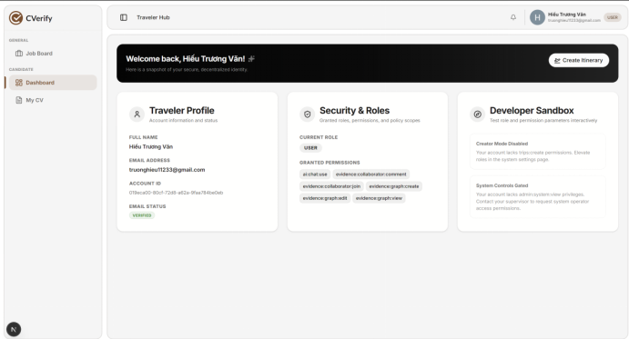
Screen 5 & 9 — CV Management (Overview): The CV management hub. Displays completion percentage, optimization suggestions, CV sections, and a right-hand sidebar for CV export controls. Screen 9 shows the same page with a scroll-down view revealing the "Digital Profile" section.
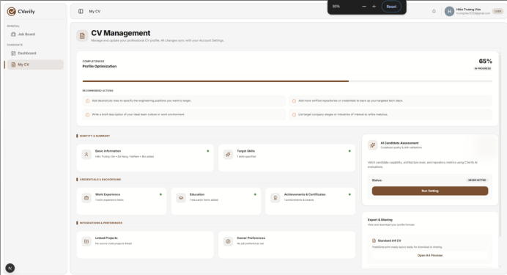
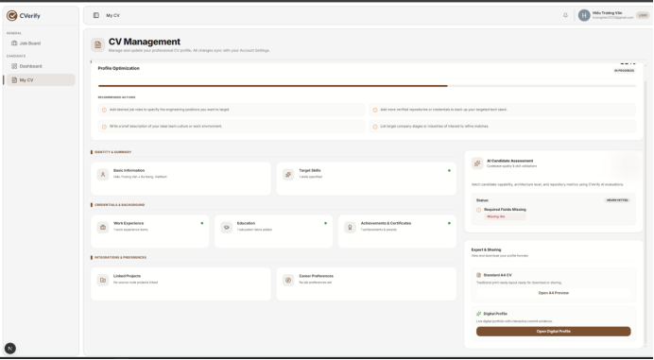
Screen 6 — Edit CV (Section-Specific Editor): A granular editing interface. The left sidebar lists alCV sections for quick navigation. Features two modes: Form Editor and Live Preview. Changes are auto-saved with a confirmation toast ("Changes saved successfully!").
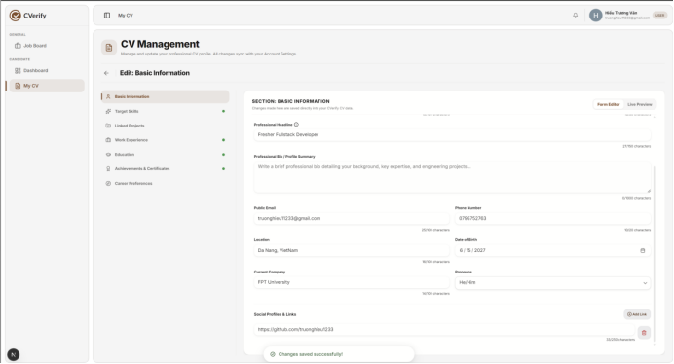
Screen 7 — Account Settings (Profile Settings): General account settings for candidates. Features an internal sidebar with four navigation categories. Profile information is dynamically synchronized with the CV Management module.
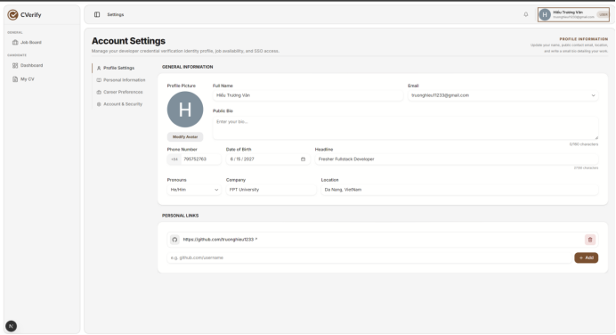
Screen 8 — Account & Security: Manages version control integrations (GitHub/GitLab), authentication methods, and active login session management.
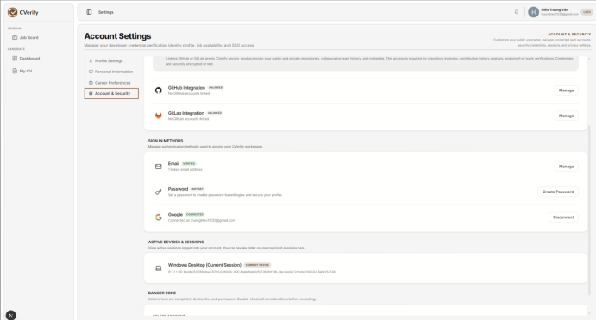
Screen 10 — Digital Profile (Public Profile): The public-facing profile page — viewable without authentication. Includes two primary tabs: "Overview & Portfolio" and "AI-Verified Assessment."
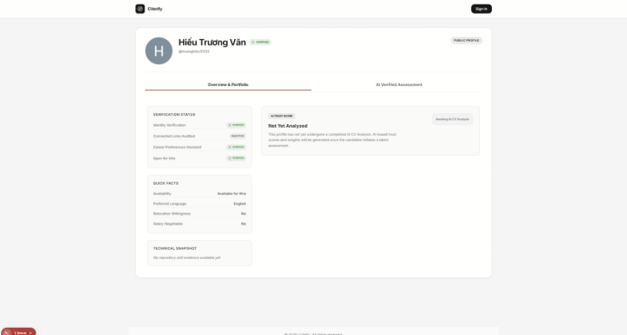

PART 2 — BUSINESS WORKFLOW (RECRUITER)
Screen 11 — Partner Console Dashboard: The central business hub. Displays high-level analytics: Active Listings, Total Bookings, and Estimated Revenue. Lists current Service Offerings below the primary metrics.
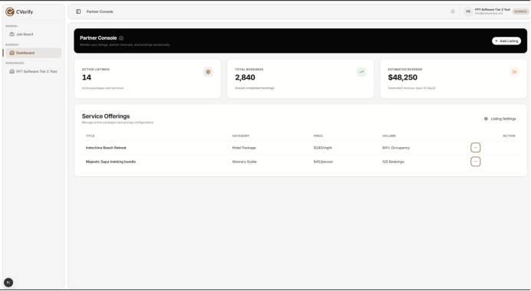
Screen 12 — Workspace Information: Detailed workspace configuration: company description, industry, benefits, contact info, office locations, and social media links.
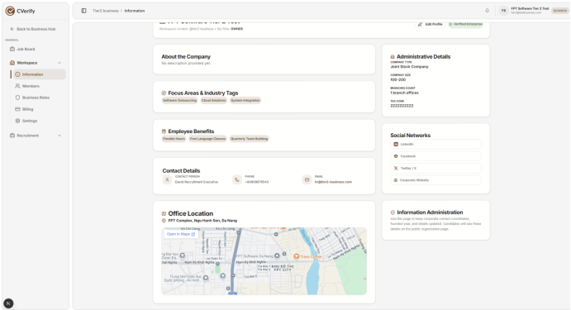
Screen 13 — Members (Member Management): Manages workspace personnel. Organized into three tabs: People Directory, Pending Invitations, and Workspace Logs. Supports filtering by status and internal roles.
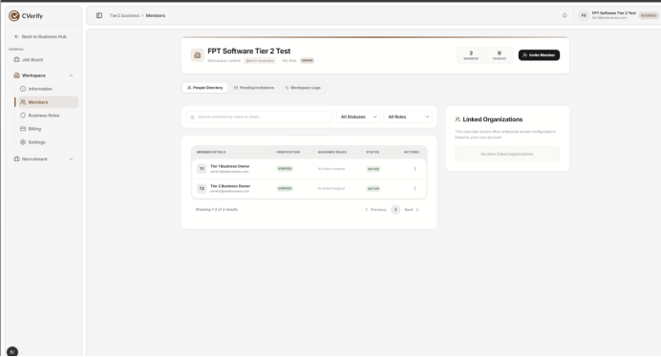
Screen 14 — Modal: Invite Organization Members: A dedicated dialog for onboarding team members. Allows administrators to add members to a "Batch List" before sending bulk invitations

.Screen 15 — Business Roles & Governance: Manages custom roles and internal permission scopes. Features four tabs: Roles Matrix, Scoped Assignments, Permission Grid, and Audit Trail Logs.

Screen 16 — JD Management (Job Description): Interface for creating and managing Job Descriptions to automate recruitment and skill-based applicant screening. Currently showing an empty state (no JDs created).
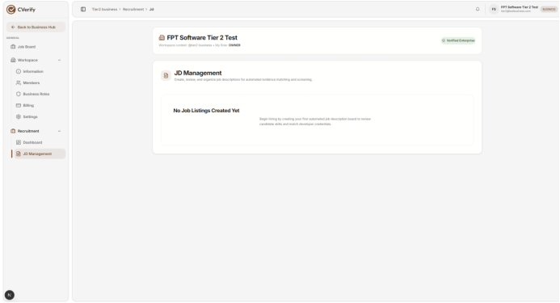

20. REQUIRED DIAGRAMS IN THE SRS
Diagram | Purpose | Chapter | Actors / Entities | Required?
Context Diagram | Describes CVerify as a black box and all external systems that interact with it | Chapter 5 | CVerify System, GitHub, Google OAuth, AI APIs, Tax API, Admin, Candidate, Recruiter | Mandatory
Use Case Diagram | High-level overview of all use cases organized by role | Chapter 13 | Candidate, Recruiter Tier 1/2, Admin, AI Service, GitHub | Mandatory
Activity Diagram – Onboarding | Flow for candidate registration and company onboarding | Chapter 8 | Candidate, System, Email Server, Admin (Tier 2) | Mandatory
Activity Diagram – AI Matching | Flow from JD posting to Explainability Report generation | Chapter 11 | Recruiter, AI Router, pgvector, Candidate Pool | Mandatory
ERD (Entity Relationship Diagram) | Full database structure with all relationships | Chapter 16 | users, candidate_profiles, repositories, cv_embeddings, organizations, job_posts, applications, audit_logs | Mandatory
Sequence Diagram – GitHub Integration | Detailed interaction when a candidate links GitHub and triggers a repo crawl | Chapter 9 | Candidate, Frontend, Backend, GitHub OAuth, GitHub API, AI Service, DB | Mandatory
System Architecture Diagram | 5-tier architecture: Presentation, API Gateway, Business Logic, AI Orchestration, Data | Chapter 6 | Next.js, ASP.NET Core, Multi-model Router, PostgreSQL, Redis, Hangfire | Mandatory
Data Flow Diagram (DFD) Level 0 | Data flow from GitHub through AI processing to database and search index | Chapter 15 | GitHub API, AI Parser, Embedding Engine, pgvector, Redis Cache | Recommended
UI Wireframe / Mockup | Interface design for each user role | Chapter 19 | Candidate Dashboard, Recruiter Dashboard, Admin Dashboard | Mandatory
Sequence Diagram – Credit Transaction | Flow for credit debit when a recruiter views a profile and reveals contact info | Chapter 10 | Recruiter, Frontend, Backend, Credit Engine, DB, Notification Service | Recommended

21. REQUIREMENT VALIDATION, TRACEABILITY AND CHANGE MANAGEMENT

21.1 SRS Completeness Checklist
Use the following checklist to assess whether the SRS is complete:
# | Criterion | Status
1 | Every requirement has a unique ID (FR-xx, NFR-xx, BR-xx) | Done
2 | Each FR is written unambiguously (no vague terms like 'reasonable', 'sufficient', 'fast' without measurable definitions) | Done
3 | Each FR has a priority (High/Medium/Low) and sprint assignment | Done
4 | Each FR is testable – it has measurable acceptance criteria | Done
5 | All 3 user roles (Candidate, Recruiter, Admin) have defined functional requirements | Done
6 | All external systems are described in the External Interface chapter (Ch. 14) | Done
7 | Non-functional requirements include specific metrics (ms, %, KB, etc.) | Done
8 | Business rules are separated from functional requirements | Done
9 | AI requirements clearly define input, output, constraints, and limitations | Done
10 | Data dictionary covers all entities, key fields, relationships, and security rules | Done
11 | Use case model contains at least 15 use cases covering all roles | Done
12 | Scope (in-scope / out-of-scope) is clearly defined | Done
13 | Assumptions and dependencies are listed | Done
14 | Diagram list has been identified and assigned to the appropriate chapters | Done
15 | Requirements Traceability Matrix (RTM) has been prepared | Pending
16 | Change management process is defined | Done
17 | Document has been reviewed by at least 2 team members | Pending
18 | Document has a cover page, table of contents, and version history | Done
19 | No conflicting requirements exist within the document | Pending
20 | All TBD items are tracked with assigned deadlines | Pending

21.2 Requirements Traceability Matrix (RTM)
The RTM maps each Functional Requirement to: Use Case → Database Entity → Test Case → Sprint:
FR ID | FR Name | Use Case | DB Entity | Test Case | Sprint
FR-01 | Candidate Registration | UC-01 | users, auth_providers | TC-AUTH-01 | Sprint 1
FR-11 | Link GitHub | UC-04 | repositories | TC-REPO-01 | Sprint 2
FR-16 | AI Skill Tree | UC-05 | cv_embeddings, candidate_profiles | TC-AI-01 | Sprint 3
FR-27 | Semantic Job Search | UC-06 | job_posts, cv_embeddings | TC-SEARCH-01 | Sprint 3
FR-31 | AI Candidate Matching | UC-11 | applications, job_posts | TC-AI-MATCH-01 | Sprint 3
FR-35 | Admin Tier 2 Review | UC-15 | organizations | TC-ADMIN-01 | Sprint 1

21.3 Change Management Process
- All changes to requirements after the SRS baseline must go through a formal Change Request (CR) process.
- Each CR must be documented with: CR ID, requestor, change description, justification, impact analysis, and priority.
- CRs are reviewed during sprint planning. Impact on deadline, scope, and resources must be assessed before approval.
- CRs must be approved by the Project Lead and Supervisor before the SRS is updated.
- Version history must be updated each time the SRS is changed (version number, date, author, summary of changes).

21.4 Version History
Version | Date | Author | Summary of Changes
v1.0 | May 2026 | CVerify Team | Initial SRS draft – 8 chapters + 3 appendices
v2.0 | June 2026 | CVerify Team | Expanded to 21 chapters: added Business Requirements, Stakeholders, Use Case Model, Data Dictionary, Business Rules, UI/UX, Diagrams, Traceability, and detailed AI Requirements

22. RELATED WORK

22.1 CV Intelligence — Parsing and Ranking
The automation of resume screening has gained significant traction in the NLP and Machine Learning communities. Early research relied on statistical methods (TF-IDF) combined with classical classifiers (SVM, Logistic Regression). The emergence of Transformer-based architectures has since revolutionized semantic comprehension in CVs.
- M’haouach et al. [R1] (2026): Proposed an automated CV classification pipeline comparing TF-IDF, DistilBERT, and Llama 3.1 embeddings. Results on 1,500 CVs demonstrated that Logistic Regression combined with Llama 3.1 embeddings achieved 99% accuracy, proving the significant superiority of LLM-based embeddings over legacy methods.
- Priyanka & Parveen [R2] (2024): Introduced DeepSkillNER, a hybrid PDCNN-Bi-GRU architecture with a CRF layer for Named Entity Recognition. It utilizes unsupervised spectral clustering to address labeled data scarcity, achieving 99.8% accuracy on real-time datasets.
- Kinger et al. [R3] (2024): Approached resume parsing via Computer Vision, combining YOLOv5 for document layout detection and DistilBERT for semantic understanding. This two-stage pipeline successfully parses multi-column, complex CV formats that traditional ATS often fail to process (96.2% accuracy).
- Priyanka & Parveen [R8] (2024): Proposed CGRUN (Convolutional GRU Network) utilizing the Artificial Gorilla Troops Optimizer to enhance K-means clustering stability for multi-level skill extraction.
Research Gap: While CV Intelligence has reached high benchmark accuracy, these methods lack mechanisms to verify the truthfulness of declared information. CVerify addresses this core gap by implementing Evidence-Based Verification derived from real code repositories.

22.2 Semantic Matching — Person-Job Fit
The Person-Job Fit domain has shifted from simple keyword matching to deep semantic representation learning. The prevailing trend (2023–2025) involves integrating Graph Neural Networks (GNNs) to model the complex relationships between candidates, jobs, and historical hiring data.
- Frazzetto et al. [R4] (2025): Proposed a GNN bipartite graph approach using 14 node types representing candidates, jobs, and LLM-extracted attributes. Tested on 62 real-world selection processes, GCNs identified 48.9% of qualified candidates, significantly outperforming traditional MLP models (8.5%).
- Xue et al. [R5] (2025): Introduced GPJFNNF, combining BERT for local semantic representation with GNNs for global representation. Its Adaptive Feature Fusion mechanism dynamically adjusts weights, eliminating the need for hard-coded parameters.
- Peña et al. [R6] (2023): Emphasized Human-Centric AI in recruitment, proposing a framework based on four pillars: utility, privacy, transparency, and fairness. Their multimodal testbed provides an audit checklist to detect demographic bias in hiring models.
Research Gap: Current methods rely entirely on self-declared data in CVs/JDs. They lack cross-validation with actual technical evidence and suffer from the "cold-start" problem when historical recruitment data is unavailable.

22.3 Job Recommender Systems (JRS)
- Ertuğrul & Bitirim [R7] (2025): Conducted a comprehensive Systematic Literature Review (SLR) covering 13 years of research via the PRISMA protocol. The SLR identified major gaps in evidence-based verification, explainability, and cold-start solutions. This confirms that evidence-based repository verification remains an untapped research frontier in JRS.

22.4 Repository Intelligence — Code-Based Assessment
The exploitation of repository data to assess technical competence is the most nascent and underexplored field in HR Technology. This is CVerify's primary technical differentiator.
- Oliveira et al. [R9] (2022): Modeled GitHub collaboration as a heterogeneous network. Crucially, they found that social metrics (stars, followers) do not correlate with technical depth, directly supporting CVerify’s decision to focus on commit graphs rather than vanity social metrics.
- Ahasanuzzaman et al. [R10] (2023): Proposed KUREC, utilizing "Knowledge Units" (KUs) to build expertise profiles from commits and pull requests. Tested on 290k commits, KUREC outperformed standard reviewer recommendation tools.

22.5 Research Gap Summary & CVerify Value Proposition
Reviewing the 10 aforementioned papers reveals four critical research gaps that CVerify is positioned to solve:
- Integration Gap: No existing solution integrates CV Intelligence (text) with Repository Intelligence (code) to create a composite, evidence-backed score.
- Integrity Gap: Existing CV parsers lack native fraud detection, originality scoring, or "score-farming" mitigation.
- Cold-Start Gap: GNN-based matching models typically require massive historical recruitment data. CVerify utilizes pgvector HNSW semantic search and Evidence-Based Knowledge Graphs to perform accurate matching for new candidates without requiring historical data.
- Explainability Gap: Existing systems function as "black boxes." CVerify provides transparent, multi-dimensional scores (8-Factor ATS Score) supported by explainable evidence, allowing both recruiters and candidates to understand the "why" behind every match.

23. RESEARCH METHODOLOGY
CVerify is designed as an AI-Native Evidence-Based Talent Intelligence system, integrating four primary technical modules: CV Intelligence, Repository Intelligence, Semantic Matching, and Trust Score Aggregation. This chapter details the design methodology, processing pipelines, and technical decision-making processes, foundational to the research-backed approaches outlined in previous sections.

23.1 System Architecture Overview
CVerify operates through a dual-stream parallel pipeline:
- (A) The CV Intelligence stream: Processes self-declared information extracted from candidate profiles.
- (B) The Repository Intelligence stream: Extracts verifiable technical evidence directly from GitHub/GitLab.
These streams converge at the Trust Score Aggregation module to generate a composite, explainable assessment metric.
Module | Data Source | Core Technique | Reference
CV Intelligence | PDF/DOCX CV Upload | Layout Detection + LLM NER + Skill Clustering | [R1, R2, R3, R8]
Repository Intelligence | GitHub/GitLab API | Heterogeneous Network + KU-based Expertise Profiling | [R9, R10]
Semantic Matching | CV Vector + JD Vector | pgvector ANN (MVP) → GNN Bipartite (Phase 2) | [R4, R5, R7]
Trust Score | CV Score + Repo Score | Weighted Fusion + Explainable Breakdown | [R6]

23.2 CV Intelligence Module

23.2.1 Layout-Aware CV Parsing
Adopting the methodology from [R3], CVerify utilizes a two-stage pipeline for CV parsing. The first stage employs document layout detection to segment the CV into logical sections (Header, Education, Experience, Skills). The second stage applies LLM-based Named Entity Recognition (NER) to extract structured entities from each segment. This approach mitigates the "garbage in, garbage out" limitation of traditional ATS when processing complex, non-standard CV formats.

23.2.2 LLM Embedding and Skill Extraction
Based on the benchmarks from [R1], CVerify utilizes high-dimensional LLM-based embeddings (text-embedding-3-large) for CV representation rather than legacy methods like TF-IDF or DistilBERT. Skill extraction adheres to the NER architecture proposed in [R2], identifying specific entity types: SKILL, TECHNOLOGY, EXPERIENCE_YEAR, EDUCATION_LEVEL, and CERTIFICATION.

23.2.3 Skill Tree Auto-Generation
Applying the clustering concepts from [R8], CVerify automatically aggregates extracted skills into a hierarchical Skill Tree categorized by domain (e.g., Frontend, Backend, DevOps, Data, Mobile) without relying on hard-coded taxonomies. The clustering logic utilizes embedding similarity within the high-dimensional space, providing a more granular and adaptive categorization than traditional K-means.

23.3 Repository Intelligence Module

23.3.1 Heterogeneous Network Construction
Following the framework in [R9], CVerify constructs a heterogeneous network from GitHub API data consisting of three node types: Developer, Repository, and ProgrammingLanguage. The edges are defined by weighted interactions: contributed_to (scaled by commit count), collaborates_with (scaled by PR interaction intensity), and uses_language. In accordance with [R9], vanity social metrics (stars, followers) are excluded from the network construction as they show no correlation with actual technical depth.

23.3.2 Knowledge Unit (KU)-Based Expertise Profiling
Extending the KUREC methodology from [R10], CVerify defines "Knowledge Units" (KUs) for key languages: TypeScript (React, Node.js, async patterns), Python (ML libraries, concurrency, decorators), and Java (Collections, Streams, Concurrent API). KU detection is performed via static analysis on commit diffs, employing time-weighted frequency to reflect the recency of expertise.

23.3.3 Fraud Detection
CVerify implements a proprietary fraud detection layer beyond those identified in surveyed literature:
- Clone Detection: Identifies abnormal rates of code copy-pasting from public repositories or AI-generated boilerplate, signaling a potential lack of original problem-solving capability.
- Contribution Originality Scoring: Analyzes the ratio of additions/deletions and file diversity to distinguish between genuine contributors and "repository inflators"—users who commit trivial, non-functional changes to artificially inflate their contribution heatmaps.
- Bot Activity Detection: Monitors commit timestamp patterns and frequency distributions to flag programmatic or automated activity that deviates from human development workflows.

23.4 Semantic Matching Module
CVerify employs a two-phase matching strategy, informed by the scalability analyses in [R4], [R5], and [R7]:
- MVP Phase (pgvector ANN Search): Candidate vectors (derived from CV embeddings) and Job vectors (derived from JD embeddings) are stored in PostgreSQL using the pgvector extension. A cosine similarity search (utilizing HNSW indexing) provides sub-100ms matching latency, allowing for real-time candidate-job matching without the need for historical recruitment data.
- Phase 2 (GNN-based Matching): As the platform accumulates historical recruitment data, the system integrates the GNN bipartite graph approach from [R4] to improve recall for minority class candidates (highly qualified applicants in large talent pools).
Bias Mitigation: The matching engine incorporates the Human-Centric AI framework from [R6]. Scoring is anchored in verified technical evidence rather than historical hiring outcomes, which actively reduces the propagation of demographic bias frequently found in legacy recruitment datasets.

23.5 Trust Score Aggregation and Explainability
The Trust Score is synthesized from three primary data sources using a dynamic, role-calibrated weighted formula:
$$\text{TrustScore} = \alpha \times \text{CVScore} + \beta \times \text{RepoScore} + \gamma \times \text{MatchScore}$$
Where $\alpha, \beta, \gamma$ are weights calibrated by specific job roles—for instance, assigning a higher weight to $\beta$ (RepoScore) for Senior Engineer roles to prioritize technical depth, or higher weight to $\alpha$ (CVScore) for management positions.
Each component is rendered separately in the UI with distinct badges for Verified (Repo-backed) and Self-Declared (CV-only) skills. This approach adheres to the Transparency Principle established in [R6], ensuring that both recruiters and candidates have full visibility into the factors influencing the ranking, thereby fostering trust and enabling an audit trail for the recruitment process.

APPENDIX B: AI MODEL ROUTING STRATEGY AND CIRCUIT-BREAKER POLICY
AI Task | Primary Model | Fallback Model | Selection Rationale
JD Analysis & Structured Extraction | GPT-4.1 (Function Calling) | Claude Sonnet 4 | Best strict JSON output and structured field accuracy.
Repository Auto-Description Generation | Gemini 2.5 Flash | GPT-4.1 mini | High throughput, low cost, smooth streaming.
Skill Tree Inference | Claude Sonnet 4 | GPT-4.1 | Superior complex reasoning; 200K context window for large codebases.
Semantic Embedding Generation | text-embedding-3-large (1536d) | Gemini text-embedding-005 | State-of-the-art MTEB score; native pgvector support.
Gap Analysis | GPT-4.1 | Claude Sonnet 4 | High-quality recommendations with structured reasoning.
Trust Score / Fraud Detection | Fine-tuned classifier | GPT-4.1 (few-shot) | Fast pattern detection in commit history at low latency.

Circuit-Breaker Policy: If the primary model returns errors on 3 consecutive requests within a 60-second sliding window, the Multi-model Router SHALL automatically switch to the fallback model and alert the Admin dashboard. The primary model is retried after a 5-minute cool-down period.

APPENDIX C: IMPLEMENTATION ROADMAP AND RISK MATRIX

Sprint Plan
Sprint | Timeline | Key Deliverables | AI Features Delivered
Sprint 1 | Weeks 1–2 | Multi-provider auth, user roles, company onboarding (Tier 1 & 2), basic CV CRUD, database schema, CI/CD pipeline | Email OTP verification; MST auto-verify workflow
Sprint 2 | Weeks 3–4 | GitHub OAuth integration, repository crawler, basic skill extraction, JD CRUD, Tier 1 recruiter pipeline dashboard | Repository Intelligence; AI Function Calling auto-description
Sprint 3 | Weeks 5–6 | pgvector setup, cv_embeddings pipeline, semantic search, ATS scoring engine, Gap Analysis endpoint, reverse JD matching | Embedding pipeline; HNSW index; 8-factor ATS ranking; Gap Analysis streaming
Sprint 4 | Weeks 7–8 | Active Window credit system, Hybrid Credit anti-harvesting, Admin dashboard (AI analytics + Tier 2 review), load testing, production deployment | AI streaming UX; Redis Semantic Cache; Fraud Detection; Explainability Reports; Daily AI Digest

Risk Matrix
Risk | Prob. | Impact | Mitigation Strategy
GitHub API rate limit exceeded during bulk crawl | High | High | Use GitHub App authentication (15K req/hr); queue-based crawler with exponential backoff; cache repo metadata for 24 hours.
AI API costs exceed project budget | Medium | High | Deploy Redis Semantic Cache before any AI feature reaches production; implement hard spending caps per environment; use Gemini 2.5 Flash for high-volume tasks.
pgvector query latency degrades at scale | Low | Medium | Tune HNSW parameters (m=16, ef_construction=64); implement connection pooling; add a read replica for search queries.
LLM output inconsistency / hallucination in structured fields | Medium | Medium | Enforce strict JSON Schema via Function Calling; add Zod validation on frontend; implement retry logic with exponential backoff on schema validation failure.
VietQR / esgoo.net MST API unavailability | Low | Medium | Cascade to secondary API source; if all sources fail, queue registration for Admin manual review rather than rejecting immediately.
Sprint timeline overrun due to AI integration complexity | Medium | High | Prioritize AI features as independent sprint items; mock AI responses in earlier sprints for UI development parallelism; designate a technical lead per AI module.

— End of Document — CVerify SRS v2.0 —
CVerify SRS v2.0 | FPT University SWP391 | June 2026 | Confidential

